PROJECT WRITEUP

**CLIENT**

Project Coordinator**:**

Project Team**:**

|  |  |
| --- | --- |
| **Student Name** | **Student ID** |
|  |  |
|  |  |
|  |  |
|  |  |
|  |  |

# 

Table of Contents

Problem statement 6

Problem 7

Vision 8

The primary point of this system is to expel the correspondence hole between the understudies and the scholastic administrator and make a situation wherein its simple to learn. The second objective of this undertaking is to deal with the reports of the understudy's questions and instructor's answers. 8

User stories 8

Admin: 8

Academic Admin: 9

Student: 9

Stakeholders 9

Stakeholder analysis 10

Project Objectives 10

Related Academic and Commercial Research 11

Software Development Methods: 16

***Agile Development Methodology:*** 16

***Waterfall Development Methodology:*** 17

***Rapid Application Development Methodology:*** 18

**Conclusion:** 18

Project Management Techniques 18

Frameworks 19

A frontend designer deals with a significant piece of coding as he takes a shot at what the genuine use sees. The three significant devices that a frontend developer works with are CSS, HTML and JavaScript. The essential job of the frontend engineer is to make a decent UI plan and guaranteeing that site has a firm format and structure with the goal that client experience can be improved. The most famous frontend structures are AngularJS, ReactJS, Backbone, SASS, Ember JS and Bootstrap. 20

In this undertaking, we have utilized Bootstrap. Bootstrap is an open-source frontend system which offers broad help for making dynamic web applications and sites. It gives layout dependent on HTML and CSS for making interface segments and offers help for the entirety of the significant programs and speed up for making responsive website pages. 20

Standards 20

**Methodology:** 21

The task was handled with agile methodology of three runs. The decision for the deft methodology was self-evident, the methodology of having numerous little advances that lead to the last item makes correspondence between the customer and the group simpler and objective situated. Managing little trashes of errands one after another permits the customer to follow the advancement of the undertaking intently and permits him to intercede promptly when something conflicts with the customer's desires. 21

**Front End:** 21

**Back End:** 21

**Initiation phase:** 21

This stage depends on the underlying gatherings with the customer. It comprise of getting the task plot from chatting with the customer what he/she requirement for the venture scope gaining information from the customer about the sort of framework he/she need, the foundation of the correspondence plan with the customer and the colleagues alongside job distribution will be done in this stage. 22

**Information gathering phase:** 22

This stage depended on various exercises performed by the group. In the beginning of the stage a gathering with the customer after the gathering the extent of the task is concluded by the undertaking director. The partner examination will be done after the finish of the extension. The clients or the clients of the framework will be met to get more understanding on what sort of individuals are going to utilize the framework. Research will be finished by the venture administrator checking comparative sites that are now made and get an understanding on what we will make. Toward the finish of this stage the specialized necessities will be concluded. 22

**Planning phase:** 22

**Design phase:** 23

**Sprint 1:** 24

This is the primary stage wherein the best possible writing computer programs is being begun with making the undertaking structure including models, controller, vaults, and administrations documents are made. After that the sign in usefulness with alongside its front end is made for each sort of client, at that point the dashboard for admin/academic admin/student are made by the group alongside the entirety of their front-end necessities. At that point all the module for client is created by the group including the survey all clients, making new clients, altering client profile, erasing a client and the reset client secret phrase by the administrator is finished. This stage significantly centers around the administrator module which additionally incorporate the age of reports and review them. Toward the finish of the stage the tests for the stage are made and the modules created in the stage are altogether tried. At that point the undertaking made till now is introduced to customer for his/her perspective and the progressions he/she needs are noted and done by the group at the earliest opportunity the task is again tried and a report for the stage is submitted. 24

**Sprint 2:** 25

**Sprint 3:** 25

**Product Demonstration:** 26

**Sign Up Page:** 26

**Login Page:** 27

**Admin Dashboard:** 27

**Users Page in Admin Panel:** 28

**Add User in Admin Panel:** 29

**Reports in Admin Panel:** 29

**Generate Reports in Admin Panel:** 30

**Academic Admin Dashboard:** 31

**Queries Form in Academic Admin User:** 32

**Reply Query Form in Academic admin User:** 32

**Appointments Form in Academic Admin Panel:** 33

**Reports Form in Academic Admin Panel:** 34

**Message Form inAcademic Admin:** 35

**Reset password Form:** 35

**Student Dashboard:** 36

**Student Queries Form:** 37

**Students Appointment Form:** 38

Product Testing 38

1) Test Admin Panel Login: 39

1. Admin can login successfully 40

2. User except admin tries to login 41

2) Test Academic admin login: 42

1. Academic admin can login successfully 43

2. User except academic admin tries to login: 44

3) Test Student login: 45

1. Student can login successfully 46

2. User except Student tries to login 47

4) Test Users: 48

1. Admin can view all users 49

2. Admin can add a single user 50

3. Admin can add multiple users 51

4. Admin can delete users 52

5) Test Admin Reports: 52

1. Admin can view previous generated reports 54

2. Admin can generate monthly report 54

3. Admin can generate yearly report 56

6) Test Academic Admin Queries: 57

1. Academic admin can view all queries sent to them 58

2. Academic Admin can reply to queries 58

7) Test Academic Admin Appointments: 59

1. Academic admin can view all appointment set by them 60

2. Academic Admin can set an appointment for a student 61

8) Test Academic Admin Reports: 62

1. Academic Admin can view previous generated reports 63

2. Academic Admin can generate monthly report 64

3. Academic Admin can generate yearly report 65

8) Test Academic Admin Message: 67

1. Academic Admin can send message to the student 68

9) Test Student Queries: 69

1. Student can view all the queries and their replies sent by them. 70

2. Student can send a query to the academic admin 70

10) Test Student Appointments: 71

10) Test Reset Password: 73

1. Admin can reset password of any user 75

2. Academic admin can reset their own password 76

3. Student can reset their own password 77

**Summary of Findings, Limitations, and Recommendations** 78

**Applications of the Admin User:** 78

**Applications of the Academic Admin User:** 78

**Applications of Student User:** 79

**Limitations** 79

**Improvements:** 79

**Conclusion:** 80

**References:** 81

# Problem statement

In the day to day life of student in a university, if a student has a query/problem and he/she needs to communicate to the academic admin, he/she must go through a channel which includes contacting the university and then the university will deliver the message to the academic admin or student have to email the academic admin and wait for their response. But as the world is evolving this is causing a problem for the students because some of the problems that students face, they need to contact the academic admin urgently , in which case going physically to the university is not always easy / or the timing is not feasible for getting the problem solved and other communication channels (for e.g. Face book, WhatsApp) are not always encouraged by academic admin members as a means of communication with the student.

Although there are some ways of communicating for students like CMS portal for university students, or online help desks but the problems with these systems is the efficiency of these systems. A lot of systems queries are posted on help desks, but students are not replied with the proper relevant material at all. And a lot of the times these queries are replied but sometimes they are given replies so late that the persons problem has only gotten finished or the answer to the query is no longer needed. A lot of times there are problems of which constant replies are needed to understand all the queries of the relevant persons and the help desk ends up replying to the initial one or 2 queries but the rest are ignored or not replied at all. This becomes a big miscommunication line or communication gap and the online help desks aren’t able to work and help the relevant personas as efficiently as they are needed to be. One more problem is that help desks are public for the most part and hence anybody can see the queries a person has asked and sometimes the individual may ask some stuff or has to discuss some problem which can be a little private and personal and those queries end up appearing online to everyone.

The problem that arises with CMS portal is that even though these systems are destined for the support of students where they can see their attendance and get their admit cards, have multiple resources available for students to get news for them, still these systems are very inefficient at responding to students complains. There are as such options available where you can register a complain, but does this complain ever get into consideration or not or does it ever gets seen remains a mystery to students, they are usually not made aware that there complain has gotten attention or is in consideration. Sometimes help desks are also a part of CMS portals but the problem remains the same that the answers are not always answered.

If we look at a typical students query regarding for example, a student has some problems with his/her GPA, and they are not sure whether they are able to qualify for their final year projects (FYPs) to get them started. now the student tries to ask the replying to this query through help desk but his query doesn’t get answered at the right time it gets answered in almost a week and this answer still has confusions since the individual might have a problem with his/her academic record/GPA and needs to discuss it a bit more privately and the help desk is taking too long to reply , so he/she might need to go to campus for their required query getting answerer , in which case they have to go through a chain of officials to reach their desired academic admin and get an appointment done or their query answered. And if his complain/ query is not responded then the solution remains to contact the concerned academic admin through means of social channels or private contact number which mostly if not always are not considered good and appreciable.

In the end, the solution remains of either calling / contacting the concerned academic admin or going on campus to student advisors, academic admin or further staff to get their query answered or their complain registered or their appointments set with the particular concerned individual.

If an academic system gets made where the students can sign in to their personal university accounts and post their queries privately from there instead of the queries becoming publicly available to be seen by all, and the portal allows the concerned academic admin to view those queries and reply them or set appointments with the particular students in order to get the problem resolved keeping in concern the timings in which academic admin is available and the particular student is also available will help eliminate the communication gap between the concerned authorities and the students.

## Problem

The problem at hand is that there is no means of direct communication between the academic admin and the students in the systems available.

## Vision

## The primary point of this system is to expel the correspondence hole between the understudies and the scholastic administrator and make a situation wherein its simple to learn. The second objective of this undertaking is to deal with the reports of the understudy's questions and instructor's answers.

## User stories

User stories work as an essential part of a project as it helps identifying the key requirements of the project in an easy to understand language without the use of difficult technical terms. These user stories tell how the user would want to interact with the system and what operations do the user expects that the system will allow performing. Hence user stories summarize the overall functionality of the project to both members, technical and non-technical. These user stories are then broken down into small tasks converting them (usually) into small coding tasks and are prioritized accordingly.

There were three types of user stories identified and developed in this project:

## Admin:

* As an admin of the system, I want to sign in/sign out of the system.
* As an admin of the system, I want to add/remove users in bulk.
* As an admin of the system, I want to reset user password.
* As an admin of the system, I want to edit/update user profile.
* As an admin of system, I want to view/generate reports.

## Academic Admin:

* As a user(academic admin) of system, I want to sign in/sign out.
* As a user(academic admin) of system, I want to reset my password.
* As a user(academic admin) of system, I want to reply to student queries.
* As a user(academic admin) of system, I want to send message to students.
* As a user(academic admin) of the system, I want to set appointments to students.
* As a user(academic admin) of the system, I want to view reports in graphic charts.
* As a user(academic admin) of the system, I want to generate report weekly/monthly.

## Student:

* As a user(student) of the system, I want to sign in/sign out.
* As a user(student) of the system, I want to reset my own password.
* As a user(student) of the system, I want to send queries.
* As a user(student) of the system, I want to see the replies to the queries.
* As a user(student) of the system, I want to confirm appointment.

# Stakeholders

In every project, stakeholders play an important role; these can be internal or external. For a project to be successful, it is important to identify the effect of each stakeholder on the project and meeting the needs, requirements, and expectations of these stakeholders. The stakeholders of this project were properly identified in the project storyboard and are as under:

1. Client
2. Users (admin, teacher, and students)
3. Project Manager
4. Project Team
5. Select key stakeholders

# 

# Stakeholder analysis

|  |  |  |  |  |  |  |  |  |  |  |  |  |
| --- | --- | --- | --- | --- | --- | --- | --- | --- | --- | --- | --- | --- |
| **Name** | **Contact Details** | | **Organizat ion** | | | **Roles/**  **Responsibilities** | | **Engaging strategy** | **Type of**  **influence** | | | **Interest In project** |
|  | |  | |  |  | |  | | |  |  | |

# 

# Project Objectives

Analyzing the problems students face in university for getting these problems resolved and/ or getting their query answered through a channel of process and the long time and effort it can take. This project will provide the means for the communication between the academic admin and students through a web-based application which will allow the students to send a query to the academic admin and the academic admin can respond to it as soon as he/she sees it. It will also provide a platform for the academic admin to set appointments for the students and students will have the right to accept the appointments if they are available.

This will resolve the basic communication problem for the students and academic admin of the educational institute and will be administered by the admin as other means of communications like WhatsApp or Facebook or Text messages are not encouraged by the institutes.

In addition to this, there will be a report generating system administered by the admin only which will allow analyzing and keeps check of the queries being asked by the students. The appointments being made by the academic admin and the problems being resolved. These reports will help to keep check of how many queries that are being asked and how many of them are being answered properly by the staff.

There will be three different interfaces for three different kinds of the user of this web-based application. First is the admin, who would have the control over adding and removing multiple academic admin and students observe and generate the reports of the academic admin and as well as the student for keeping track of the communication and queries resolved between them.

Secondly, the main academic admins expected to contemplate and disentangle their students’ problems after methodically assigning the consultation appointment, are allowed to send message to students and view/generate reports of queries in graphic charts weekly and monthly.

And Lastly, the students who are simply considered to request their particular queries to respective academic admin.

All of the users are allowed to change/update their passwords and log in and out. And the admin can only change the user profile and add/remove new users.

This solution provides a means to make the academic admin and student communication in an institute efficient and easy.

# Related Academic and Commercial Research

E-learning or electronic learning stages encourage conveyance of the information range to the learning network through data and correspondence advancements. The exchange of information happens from specialists to students, and externalization of the information move is critical. In the e-learning condition, the students look for subject skill to explain their subject questions, and a student inquiry can be steered to a specialist for externalization of master information gave the student knows the subject master or the ability gathering. Be that as it may, students new to e-learning frameworks don't know about the mastery gathering to which the inquiry ought to be sent, which brings about time delays, non-reaction, wrong arrangements and loss of information catch. A few models have been proposed to determine this errand, yet hitherto, these endeavors have concentrated totally on restoring the most acquainted individuals as specialists on a specific subject to recover important information. To address this issue, we propose a methodology that externalizes the implied information regarding a matter master by making a powerful question taking care of framework that consequently moves a client inquiry to the best subject master.

Student Information Management systems gives a straightforward interface to support of student information. It very well may be utilized by instructive organizations or schools to keep up the records of understudies without any problem. The creation and the board of exact, cutting-edge data with respect to student academic record are fundamentally significant in the college just as schools. Student Information Management System all sort of understudy subtleties, scholastic related reports, school subtleties, course subtleties, educational plan, group subtleties, situation subtleties and other asset related subtleties as well. It tracks all the subtleties of a student from the very beginning as far as possible of the course which can be utilized for all detailing reason, following of participation, progress in the course, finished semesters, years, coming semester year educational program subtleties, test subtleties, venture or some other task subtleties, last test of the year result and all these will be accessible through a safe, online interface implanted in the school's site. It will likewise have staff subtleties, clump execution subtleties, student subtleties in all perspectives, the different scholastic notices to the staff and understudies refreshed by the school organization. It likewise encourage us investigate all the exercises occurring in the school, Various reports and Inquiries can be created dependent on immense choices identified with understudies, group, course, workforce, tests, semesters, accreditation and in any event, for the whole school.

After studying multiple research studies, it indicated that student support systems are essential in institutions for the better learning of its students. Inside the institution, the resolving of queries is done face to face which sometimes can acquire a lot of time too. Besides this it is not necessary that a student is always able to be on campus for answers of his/her query or the corresponding academic admin member is always available.

According to a research, it states that online student support systems are not only essential for distance learning but for collaborative learning too. This provides a single platform for student queries and for its quick responses[1]. It is also proved in multiple research studies and frameworks that student support system are used as factor of quality measure for better student development [2].

For this reason online academic/student support systems need to be an essential part of every institute where the system is available 24/7 [3] , and the students can ask their queries at anytime from anywhere and the staff/faculty can answer their queries as soon as they see it. This not only eases but eliminates a communication gap between the academic admin and the students.

In 2017 a study was show cased in which the paper presented a generic mechanism methodology reasonable for giving academic advising in the college framework. It proposes another model for e-Academic Admission Framework as an electronic application. The analysts have made a framework which encourages the academic guides to effectively give their students with whatever vital guidance. The framework can effectively explore the plan and usage of the design and implementation to facilitate this activity. The proposed model has brought about a model that empowers both the staff and counsel to get to so they can cause a to catch up of the students objections and their proposition and remarks. Likewise, the model empowers the students to raise their objections and present their recommendations in whatever subjects. In the long run, the model backings division heads in running their areas of expertise effectively through the KPIs reports they get.

Another examination in 2011 shows the developed of a grumbling dealing with framework. The manual managing procedure of dealing with grumblings among customers and the school staff has been abused. The motivation behind the paper is to sum up the discoveries of a study of UK colleges about how their sites are overseen and resourced, which innovations are being used, and what are viewed as the fundamental issues and needs. Structure/procedure/approach – The paper depends on a web‐based survey appropriated in summer 2006, which got 104 usable reactions from 87 foundations. Discoveries – The study indicated that some web groups were situated in IT and some in outside relations, yet in the two cases the website ordinarily served inside and outer crowds. The job of web administrator is incompletely the executives of assets, time and individuals, somewhat about promoting and contact and mostly additionally worried about increasingly specialized viewpoints including interface plan and HTML. In any case, it is a various job with a wide spread of obligations. Overall web groups were generally little. Three‐quarters of reacting foundations had a CMS, yet explicit frameworks being used were differing. 60% had an entry. There was proof of expanding utilization of online journals and wikis. The key driver for the site is understudy enrollment, with instituitional notoriety and data to partners additionally being significant. The greatest saw shortcomings were keeping up consistency with reverted content creation and money of substance; absence of resourcing a key danger while exhaustiveness was a key quality. Current and wished‐for ventures pointed again to the assorted variety of the area. Research constraints/suggestions – The absence of similar information and troubles of deciphering reactions to shut inquiries where respondents could have very unique status (mostly reflecting disparate examples of administration of the web over the area) make issues with the dependability of the examination. Functional ramifications – Data about resourcing of web the executives, innovation being used, and so on at practically identical establishments is priceless for professionals in their endeavors to pick up assets in their own specific situation. Inventiveness/esteem – Design/system/approach – The paper depends on a web‐based poll disseminated in summer 2006, which got 104 usable reactions from 87 organizations. Discoveries – The overview indicated that some web groups were situated in IT and some in outside relations, yet in the two cases the website normally served inner and outer crowds. The job of web director is halfway administration of assets, time and individuals, somewhat about advertising and contact and mostly likewise worried about increasingly specialized viewpoints including interface plan and HTML. Be that as it may, it is a various job with a wide spread of duties. All in all web groups were generally little. Three‐quarters of reacting foundations had a CMS, yet explicit frameworks being used were various. 60% had an entryway. There was proof of expanding utilization of websites and wikis. The key driver for the site is understudy enlistment, with institutional notoriety and data to partners likewise being significant. The greatest saw shortcomings were keeping up consistency with lapsed substance creation and cash of substance; absence of resourcing a key danger while exhaustiveness was a key quality. Current and wished‐for ventures pointed again to the decent variety of the segment. Research restrictions/suggestions – The absence of similar information and troubles of deciphering reactions to shut inquiries where respondents could have very extraordinary status (somewhat reflecting different examples of administration of the web over the segment) make issues with the unwavering quality of the examination. Functional ramifications – Data about resourcing of web the board, innovation being used, and so forth at tantamount establishments is significant for professionals in their endeavors to pick up assets in their own specific circumstance. The advanced education segment is described by exceptional worldwide rivalry for global understudies. This is driving colleges to put more noteworthy need on the understudy understanding and, specifically, understudy fulfillment and maintenance. Be that as it may, an under-looked into territory is understudy grievance conduct. By seeing how understudies respond to poor encounters; the possible effect on the learning and showing experience, fulfillment evaluations and at last global understudy enrollment can be surveyed, and suitable systems actualized.

In 2010 a study has presented a hypothesis of credibility and conformity in direction of behaviour orientation which extended the complain understandings and also, examinations of complain discussions. The examination states that anticipated results for both the online complaining image and the relationship with the executives along with using credibility services as a basis for online customer satisfaction.

In 2009 a study has proposed another path for demonstrating and arranging complaint registration situations associated with client firm discussions. These discussions were planned as labelled charts, where the firm and customer can convey to trade and transport their perspectives.

In 2008 a study has showcased the importance of complain management as a source of learning. Up to this point, the thought of organizational learning has not however been brought into the subject of complain dealing/ handling. Therefore, an examination has been directed to adjust a model for organizational learning on the how to of the idea of complaint management and handling. The research results have demonstrated that an assortment of objection taking care of practices can be characterized along two fundamental constituents which are Information Learning or Interactive Learning. These practices fill in as direction for updating the learning process through complaints.

Another study in 2008 has introduced a characteristic English mobile application interface that could be used to document complains. The objective was to utilize the accessible web-based interface system and give a prompt complaint registration. The framework has helped residents to record the complaints and attempt to get reward through their cell phone in their natural language.

Another study in 2008, has proposed a strategy for advancing complaint handling and taking care of these complaints by means of a programmed email classification framework which isolates complaints from non-complaints.

Consequently, complain overseeing has no longer become timewasting. In addition, the procedure has gotten more effective. The categorizing framework intermixes conventional content information with new information relating to the linguistic style of an email.

A research in 2008 showcases the developments of an Agent based Complaint Management system (ACM) run by web application called e-complaints for students and academic staff of the Faculty of Computer Science and IT (Information Technology). students could submit questions about their academic problems with their staff. This framework was competent of at the same time enlisting each and every single complaint and giving replies/feedback. This was expected to update the current (CMS) with the software agent. The software agent that was used as an operator assistant to transfer the query messages to the complaint management department. This ACM could perceive the complaint manager to whom the complain would be sent with the least human impedance through library keyword recognition.

A study in 2007 indicated that some web groups were situated in IT and some in external relations, yet in the two cases the webpage normally served interior and outer crowds. The job of web chief is somewhat the executives of assets, time, and individuals, halfway about showcasing and contact and mostly additionally worried about increasingly specialized angles including interface plan and HTML. In any case, it is a differing job with a wide spread of duties. All in all, web groups were moderately little. Three‐quarters of reacting organizations had a CMS; however explicit frameworks being used were assorted. 60% had a gateway. There was proof of expanding utilization of web journals and wikis. The key driver for the site is understudy enlistment, with institutional notoriety and data to partners likewise being significant. The greatest saw shortcomings were keeping up consistency with regressed content creation and money of content; absence of resourcing a key threat while being comprehensive was a key quality. Current and wished‐for ventures pointed again to the assorted variety of the part.

## Software Development Methods:

### **Agile Development Methodology:**

Agile software development method depends on the thought that changes do happen during the development time frame and certainty of these changes. This model acknowledges that changes will happen all through the software development process and permits the developing team to deal with the progressions viably and productively. In this procedure, the tasks are divided into small chunks of tasks called sprints. As the product advancement proceeds in little bits, testing process additionally goes inseparably with the improvement procedure. In a large portion of the cases, testing process in arranged and structured even before the real advancement of programming begins. Aside from that, persistent client correspondence is exceptionally energized, so that when client feels that any change is required, he speaks with the task director to diminish the expense of actualizing changes at any later stage.

There are four essential standards or qualities that are upheld in this technique:

1. Working software is a higher priority than extensive documentation.
2. Associations and correspondence are given significance over utilizing thorough improvement procedures.
3. Client coordinated effort is a higher priority than the agreement arrangement.
4. Changes ought to be embraced and reacted to than arranging and adhering to it.

The instances of most regularly utilized coordinated programming systems are Extreme Programming (XP), Lean Development, Scrum etc.

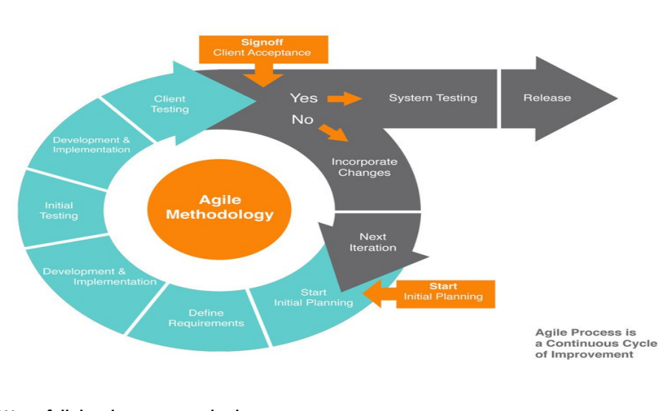

### **Waterfall Development Methodology:**

Waterfall Development Model is a methodology that is viewed as the traditional method for software development. This strategy is an increasingly inflexible and linear development model that comprises of a few phases concentrating on accomplishment of various objectives. In this model, the past stage or step must be finished so as to continue to the following stage and once a stage has been finished, it can't be changed, or alterations are not possible. Hence, it is not possible to return to the past stages to execute any changes. The projects which have stable necessities and targets are clear can utilize this software development model.

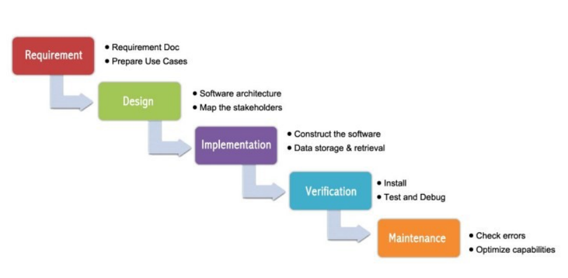

### **Rapid Application Development Methodology:**

Rapid Application Development (RAD) is a linear and part-based programming advancement model. This model has relatively short development lifecycle and appropriate for the activities where necessities of the customer are surely known and there are less technical risks. In the event of huge projects, modularization might be performed this implies different RAD groups work on the task. However, development teams should comprise of individuals who are profoundly talented, and clients of the framework are educated.

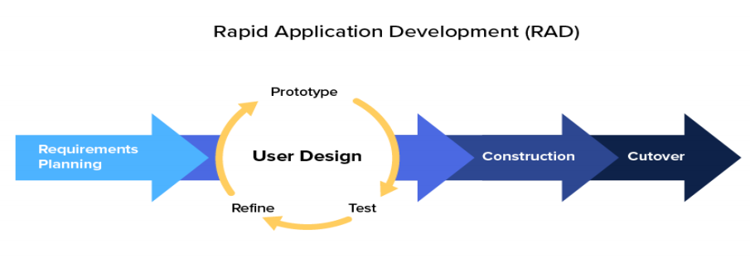

## **Conclusion:**

For Academic Support System, Agile methodology was chosen as having numerous little steps that lead to the final product makes correspondence between the customer and the team simpler and goal oriented.

## Project Management Techniques

Gantt Chart and Microsoft Project was used to manage the Academic Support System project.

**Gantt Chart**

A Gantt chat is an instrument that is utilized to represent the course of events of an undertaking and runs or components included. It is extremely valuable device in speaking to the whole course of events of one or a few tasks. It assists with distinguishing achievements that ought to be accomplished whenever and undertakings that must be finished so as to accomplish these achievements. In venture Academic Support, we have utilized Gantt chart to partition the accessible time in type of runs as a component of the light-footed programming advancement approach.

**Microsoft Project**

Microsoft Project is an undertaking the board programming item, created and sold by Microsoft. It is intended to help an undertaking supervisor in building up a calendar, doling out assets to assignments, following advancement, dealing with the spending plan, and examining remaining tasks at hand.

## Frameworks

**Back-end Development Frameworks**

The backend engineer works with a gigantic scope of libraries, web administrations, APIs and so forth. The backend engineer is liable for the fundamental usefulness of the framework, ensuring that diverse web administrations are conveying and, structuring and actualizing database frameworks. There are different systems accessible for backend advancement, for example, Express, Django, Spring and Laravel. These structures give base to creating programming all the more proficiently and viably by utilizing custom programming with an enormous number of documents in libraries. In any case, it is an individual decision of the backend designer that which structure suits best to the task issue and in the event that he needs to utilize any system or not. Also, there are various structures for various programming dialects. As we have utilized PHP for backend improvement, the accessible mainstream systems are Laravel and CakePHP. In our task, engineer has not utilized any of the backend structures however has finished this venture on center PHP. He just utilized Notepad++ to compose the code. This permits a software engineer to work o the task issue all the more autonomously and can code openly.

**Front-end Development Frameworks**

## A frontend designer deals with a significant piece of coding as he takes a shot at what the genuine use sees. The three significant devices that a frontend developer works with are CSS, HTML and JavaScript. The essential job of the frontend engineer is to make a decent UI plan and guaranteeing that site has a firm format and structure with the goal that client experience can be improved. The most famous frontend structures are AngularJS, ReactJS, Backbone, SASS, Ember JS and Bootstrap.

## In this undertaking, we have utilized Bootstrap. Bootstrap is an open-source frontend system which offers broad help for making dynamic web applications and sites. It gives layout dependent on HTML and CSS for making interface segments and offers help for the entirety of the significant programs and speed up for making responsive website pages.

## Standards

Measures have a significant impact in the guideline of the product creation and its organization. Guidelines are created and affirmed by various national and worldwide associations or other expert social orders, for example, Australian Computer Society (ACS). Thus, every product improvement venture needs to observe these norms so as to accomplish wanted quality, practicality and ease of use.

**Software Engineering Standards:** The product designing gauges are utilized in all parts of programming industry these days. These guidelines covers devices, forms, strategies, wording, framework reuse, etc. These are more than 200 dynamic or filed guidelines that are distributed by ISO and IEEE. These are liable for giving a typical structure to designers, analyzers, clients, partners, experts and chiefs who are mindful or influenced by the advancement of the product frameworks.

**Document Standards:** Documentation assumes a significant job in any product improvement venture. Documentation in this undertaking is completed by the gave layouts and configurations which are adhering to the gauges of industry. For instance: Project storyboard, moment of meeting and different reports.

**Testing Standards:** Application testing is additionally a basic piece of programming improvement extends and decide the general nature of the item being created. It is of most extreme significance for the item to be tried, approved and checked among industry principles and as indicated by the customers necessities.

# **Methodology:**

## The task was handled with agile methodology of three runs. The decision for the deft methodology was self-evident, the methodology of having numerous little advances that lead to the last item makes correspondence between the customer and the group simpler and objective situated. Managing little trashes of errands one after another permits the customer to follow the advancement of the undertaking intently and permits him to intercede promptly when something conflicts with the customer's desires.

## **Front End:**

The Front end is based on HTML5, Bootstrap and JSP which will provide a responsive interface for the users and a user-friendly GUI.

## **Back End:**

The Back end is built on Java Spring Boot framework which will provides means to complete all the functional requirements of the project. MySQL is used to build the database of the project that will be integrated with the Spring Boot framework.

The project comprised of four different phases:

## **Initiation phase:**

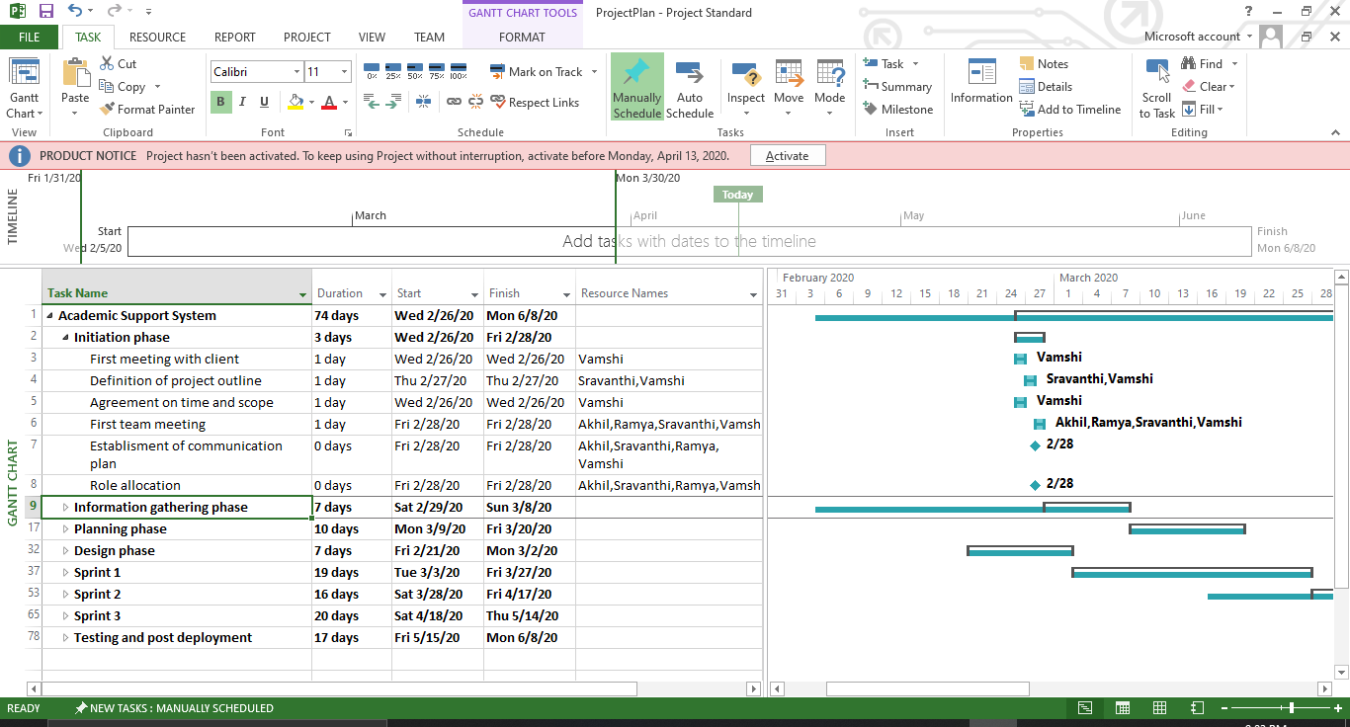

**Gantt chart 1: Initiation Phase**

## This stage depends on the underlying gatherings with the customer. It comprise of getting the task plot from chatting with the customer what he/she requirement for the venture scope gaining information from the customer about the sort of framework he/she need, the foundation of the correspondence plan with the customer and the colleagues alongside job distribution will be done in this stage.

## **Information gathering phase:**

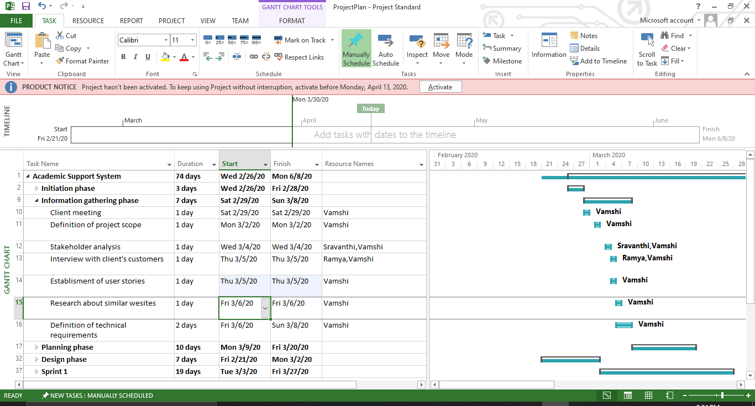

**Gantt chart 2: Information Gathering Phase**

## This stage depended on various exercises performed by the group. In the beginning of the stage a gathering with the customer after the gathering the extent of the task is concluded by the undertaking director. The partner examination will be done after the finish of the extension. The clients or the clients of the framework will be met to get more understanding on what sort of individuals are going to utilize the framework. Research will be finished by the venture administrator checking comparative sites that are now made and get an understanding on what we will make. Toward the finish of this stage the specialized necessities will be concluded.

## **Planning phase:**

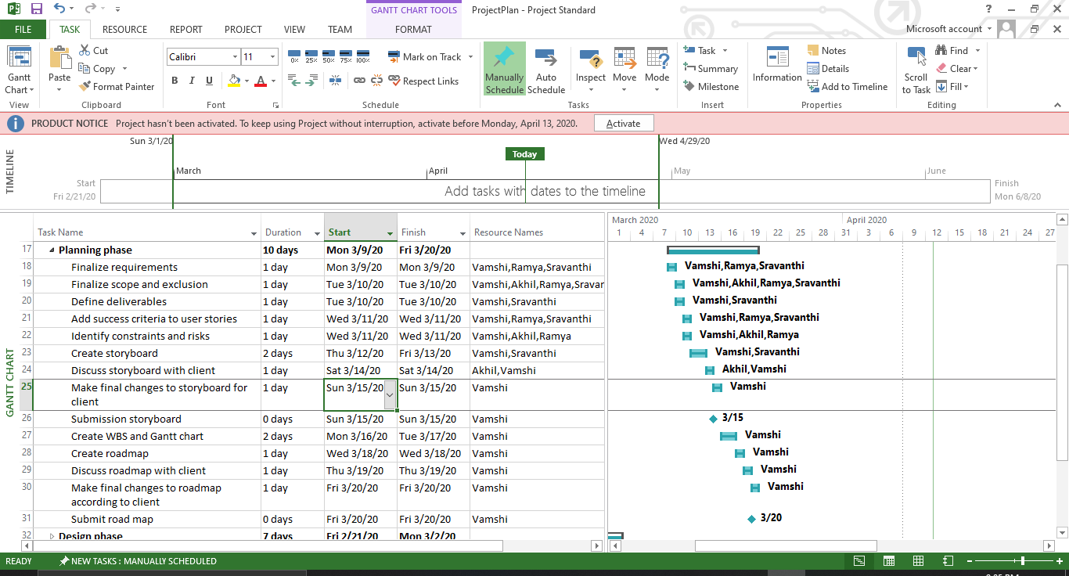

**Gantt chart 3: Planning Phase**

This stage is one of the most significant periods of the venture improvement as in this stage all the arranging of the task is finished. In this stage the necessities, degree and rejections are concluded by the group. The last expectations of the task are characterized, the acknowledgment measures of the client stories and the dangers and limitations are characterized by the colleagues. The storyboard of the undertaking is made and submitted to the customer, the progressions proposed by the customer in it are finished by the group in a split second and last accommodation of the storyboard is done to the customer. The Work Breakdown Structure alongside the Gantt graph and the guide of the task are made, talked about with the customer and the progressions proposed by the customer and last accommodation of the guide is done in this stage.

## **Design phase:**

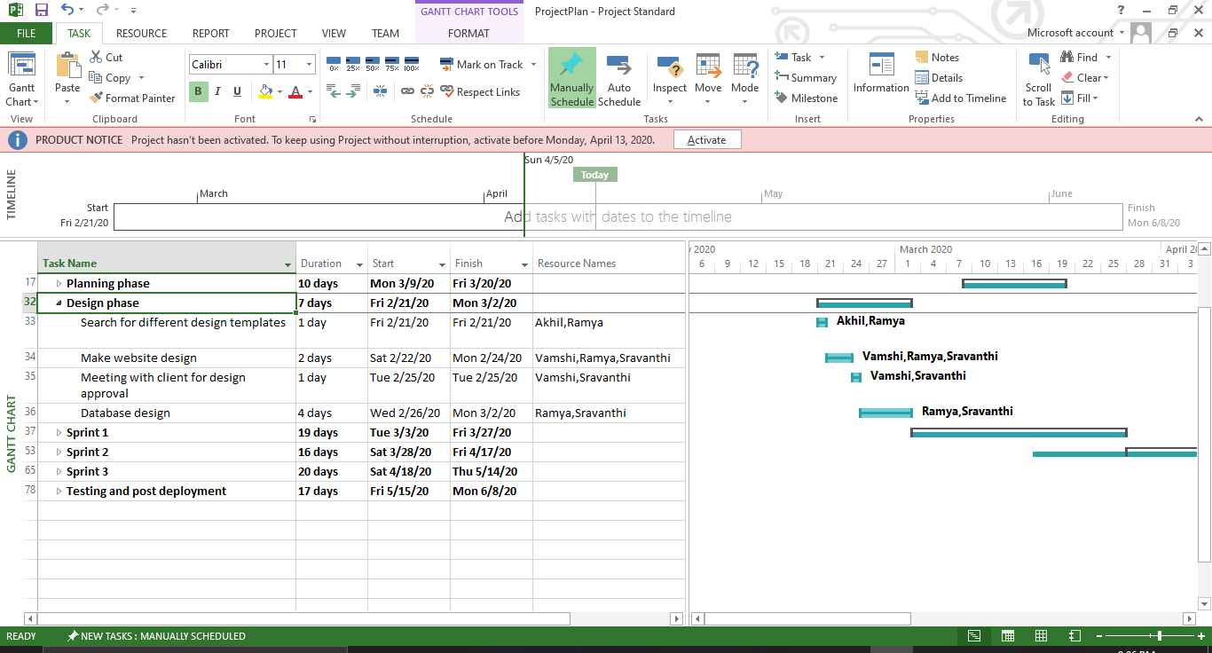

**Gantt chart 4: Design Phase**

This stage is one of the most significant periods of the product improvement as in this stage all the arranging of the venture is finished. In this stage the prerequisites, extension and prohibitions are settled by the group. The last expectations of the venture are characterized, the acknowledgment measures of the client stories and the dangers and imperatives are characterized by the colleagues. The storyboard of the task is made and submitted to the customer, the progressions proposed by the customer in it are finished by the group right away and last accommodation of the storyboard is done to the customer. The Work Breakdown Structure alongside the Gantt diagram and the guide of the undertaking are made, talked about with the customer and the progressions proposed by the customer and last accommodation of the guide is done in this stage.

## **Sprint 1:**

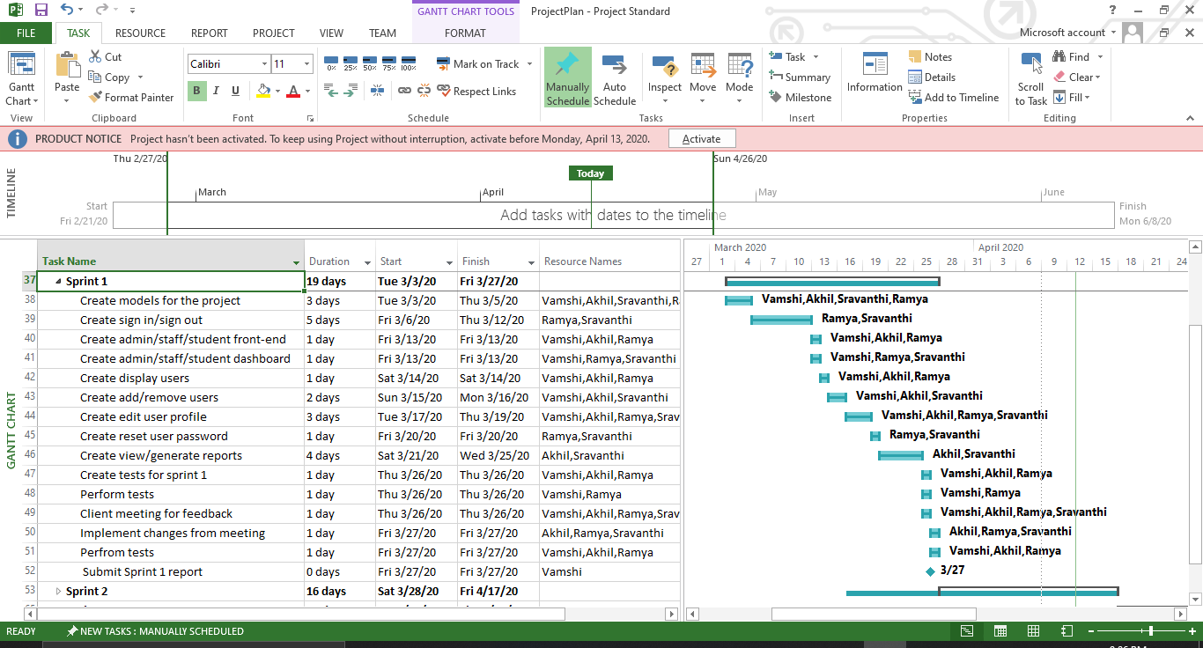

**Gantt chart 4: Sprint 1**

## This is the primary stage wherein the best possible writing computer programs is being begun with making the undertaking structure including models, controller, vaults, and administrations documents are made. After that the sign in usefulness with alongside its front end is made for each sort of client, at that point the dashboard for admin/academic admin/student are made by the group alongside the entirety of their front-end necessities. At that point all the module for client is created by the group including the survey all clients, making new clients, altering client profile, erasing a client and the reset client secret phrase by the administrator is finished. This stage significantly centers around the administrator module which additionally incorporate the age of reports and review them. Toward the finish of the stage the tests for the stage are made and the modules created in the stage are altogether tried. At that point the undertaking made till now is introduced to customer for his/her perspective and the progressions he/she needs are noted and done by the group at the earliest opportunity the task is again tried and a report for the stage is submitted.

## **Sprint 2:**

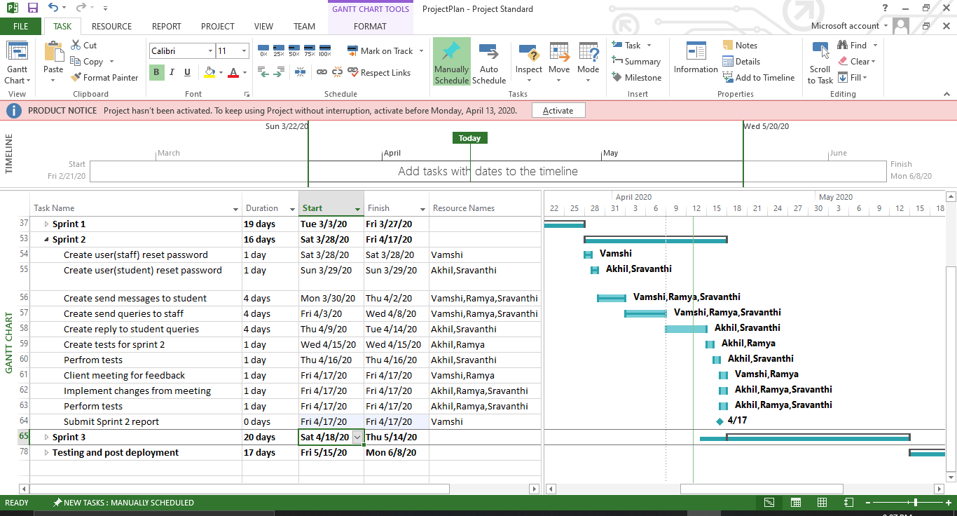

**Gantt chart 5: Sprint 2**

At the beginning of the stage the choice to reset the secret phrase of their own record is created in the user (academic admin) and user (student) modules. At that point the sending message and questions modules are created in the two modules. This stage significantly centers around the user (academic admin) and user (student) modules. Toward the finish of the stage the tests for the stage are made and the modules created in the stage are completely tried. At that point the venture made till now is introduced to customer for his/her perspective and the progressions he/she needs are noted and done by the group as quickly as time permits the undertaking is again tried and a report for the stage is submitted.

## **Sprint 3:**

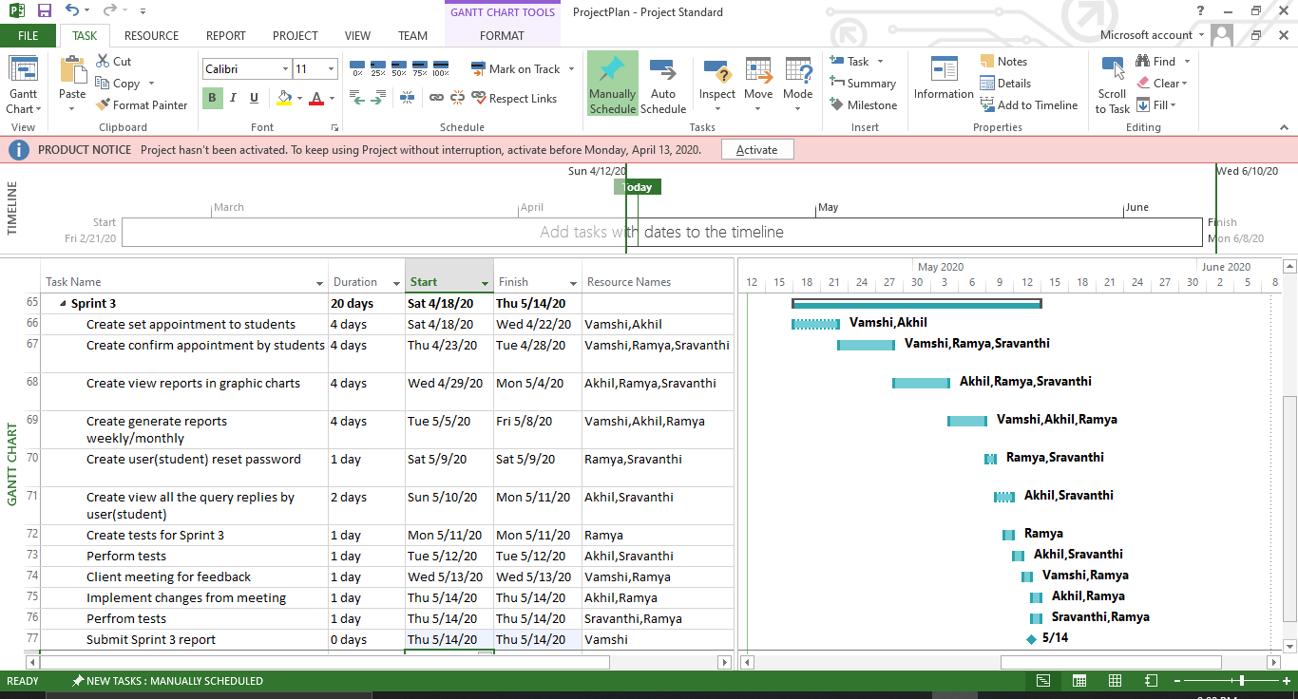

**Gantt chart 6: Sprint 3**

This is the last stage for the programming of the venture it is begun with making the arrangements module in the undertaking. After that the center is occupied to the making of the produce graphical reports by the scholastic administrators and the other residual functionalities which were not executed appropriately or left in view of the reliance on different modules are finished in this stage. Toward the finish of the stage the tests for the stage are made and the modules created in the stage are completely tried. At that point the undertaking made till now is introduced to customer for his/her perspective and the progressions he/she needs are noted and done by the group as quickly as time permits the venture is again tried and a report for the stage is submitted.

# **Product Demonstration:**

## **Sign Up Page:**

This is the main sign up page for all the users.

**Figure 1: Sign Up Page**

## **Login Page:**

This is the main login page for all users.

**Figure 2: Login Page**

## **Admin Dashboard:**

This the main admin panel through which the user can either move to the user’s page or the reports page for further work.

**Figure 3: Admin dashboard**

## **Users Page in Admin Panel:**

Here the admin user can view this list of users.

**Figure 4: Users Page**

## **Add User in Admin Panel:**

Scrolled down on the user page and the admin can add user either a single entry at a time or in bulk through a csv file.

**Figure 5 & 6: Add user page**

## **Reports in Admin Panel:**

The reports page shows the generated report lists that can be viewed.

**Figure 7: Reports in admin panel**

## **Generate Reports in Admin Panel:**

This allows the admin to generate desired monthly and yearly generation of reports.

**Figure 8: Shows monthly/yearly generation of reports**

## **Academic Admin Dashboard:**

This displays the academic admin dashboard when the academic admin logs in.

**Figure 9: Academic Admin Dashboard**

## **Queries Form in Academic Admin User:**

This allows the academic admin to see all the queries that he/she has received and can reply by clicking on reply query.

**Figure 10: Queries Form**

## **Reply Query Form in Academic admin User:**

Through this form the academic admin user can reply to the queries of the students.

**Figure 11: Reply Query Form**

## **Appointments Form in Academic Admin Panel:**

Through this form the academic admin can set appointments with the student which the student needs to confirm through their user for the appointment to take place.

**Figure 11: Appointments Form**

## **Reports Form in Academic Admin Panel:**

Through this form the academic admin can generate yearly and monthly reports.

**Figure 12 &13: Reports Form in Academic Admin User**

## **Message Form inAcademic Admin:**

Through this form the academic admin can send the students a message regarding an appointment, query, or a subject.

**Figure 14: Message Form in Academic Admin User**

## **Reset password Form:**

Through this from all the users can reset their password.

**Figure 15: Reset Password Form**

## **Student Dashboard:**

When the student loans in the system, it directs it to the student dashboard.

**Figure 16: Student Dashboard**

## **Student Queries Form:**

Through this form the students can send their queries to the concerned academic admin for further replies, appointments, and procedures. And can see further replies by the academic admin.

**Figure 17: Student Query Form**

## **Students Appointment Form:**

Through this, student can confirm their appointments set by the academic admin if they are available on those days and hours.

**Figure 18: Student Appointment Form**

# Product Testing

A test case is a record/document which has a lot of conditions or activities that are performed on the final application productto check the normal usefulness of those features.

Test cases depict a thought that will be tried, without itemizing the specific strides to be taken or information to be utilized. For instance, in an experiment, you archive something like 'Test if coupons can be applied on genuine cost'. This does not make reference to how to apply the coupons or whether there are various approaches to apply. It likewise does not specify if the analyzer utilizes a connect to apply a rebate, or enter a code, or have a client care apply it. They offer adaptability to the analyzer to choose how they need to execute the test.

The key need of a test case is to guarantee if various features inside an application are functioning true to form. It enables the tester, to approve if the product is free from defects andif it is filling in according to the desires for the end clients. Different advantages of test cases include:

* Test cases guarantee great test inclusion.
* Help improve the nature of programming,
* Diminishes the maintenance and software support costs.
* Help confirm that the product meets the end client prerequisites.
* Permits the tester to think altogether and approach the tests from however many points as could reasonably be expected.
* Test cases are reusable for the future – anybody can reference them and execute the test.

Thus, these are a couple of reasons why testcases are very valuable in software testing. Test cases are ground-breaking relics that fill in as a decent wellspring of truth for how a framework and a specific component of programming work.

The Testing of the project was done in all the phases of the project development, after each sprint completion the testing was done, and the potential errors were resolved by the team of developers. The unit tests were also written to test the internal functionality of the code. In this way the code was thoroughly tested using white box techniques.

After completion of each phase the product is tested by several users using the black box techniques to check the functionality of code by using the application. Then the errors were resolved after each phase to make the client satisfied and check the acceptance criteria along with it, whether it is fulfilling the criteria or not.

In this way the whole application was tested by the team and the potential errors were resolved when they were found.

## Test Admin Panel Login:

|  |  |  |  |  |  |  |
| --- | --- | --- | --- | --- | --- | --- |
| ID | Scenario | Preconditions | Steps involved | Expected Result | Actual Result | Status |
| 1 | Admin can login successfully | Admin already have the email and password | Enter correct password and email.  Then click on Login button. | Admin login to the system. | Admin login to the system. | **Passed** |
| 2 | User except admin tries to login to the system | User does not have the email or password of the admin account. | Enter invalid email or password.  Then click on Login button. | Username/Password/Role incorrect | Username/Password/Role incorrect | **Passed** |

### Admin can login successfully

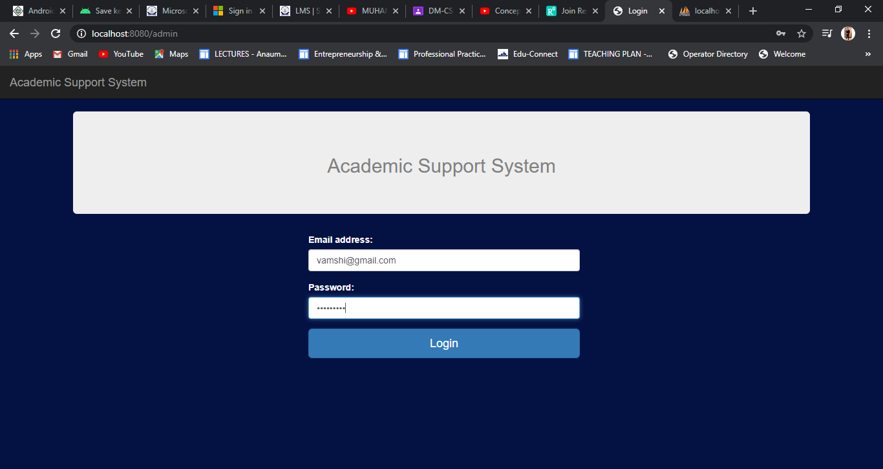

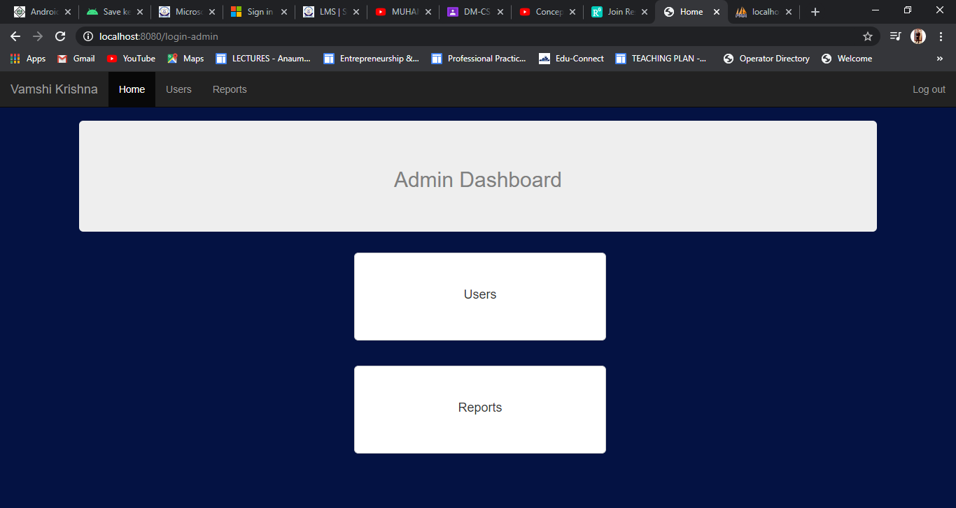

### User except admin tries to login

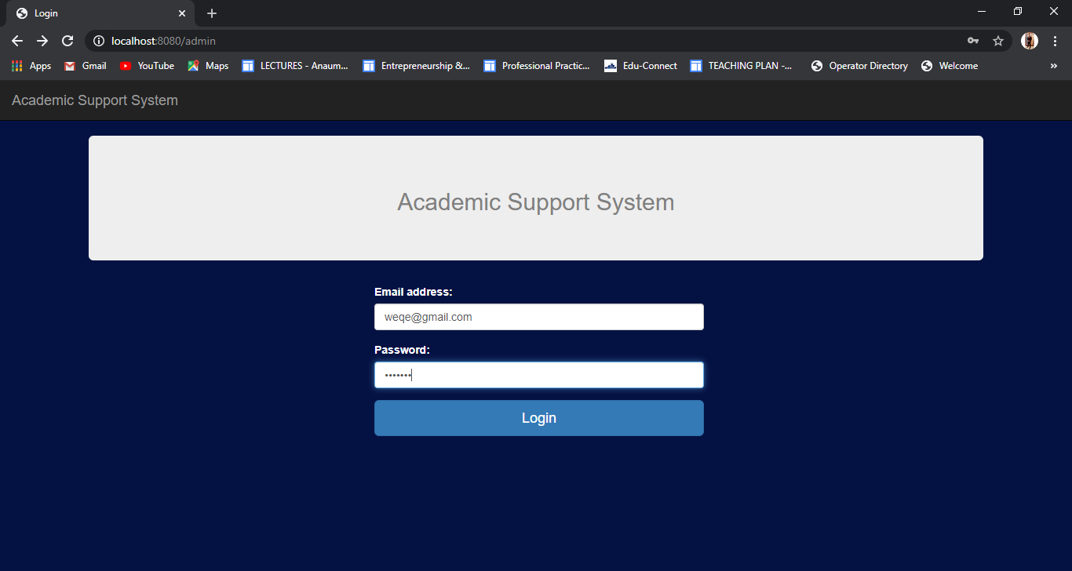

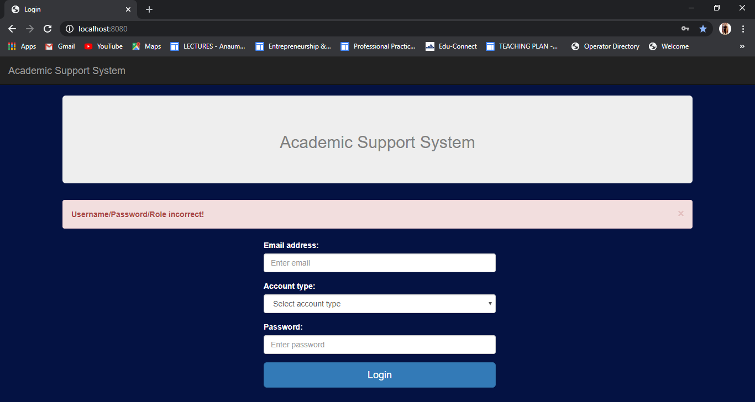

## 2) Test Academic admin login:

|  |  |  |  |  |  |  |
| --- | --- | --- | --- | --- | --- | --- |
| ID | Scenario | Preconditions | Steps involved | Expected Result | Actual Result | Status |
| 1 | Academic Admin can login successfully. | Academic Admin already have the email and password | Enter correct password and email.  Then click on Login button. | Academic Admin login to the system. | Academic Admin login to the system. | **Passed** |
| 2 | User except academic admin tries to login to the system. | User does not have the email or password of the admin account. | Enter invalid email or password.  Then click on Login button. | Username/Password/Role incorrect | Username/Password/Role incorrect | **Passed** |

### Academic admin can login successfully

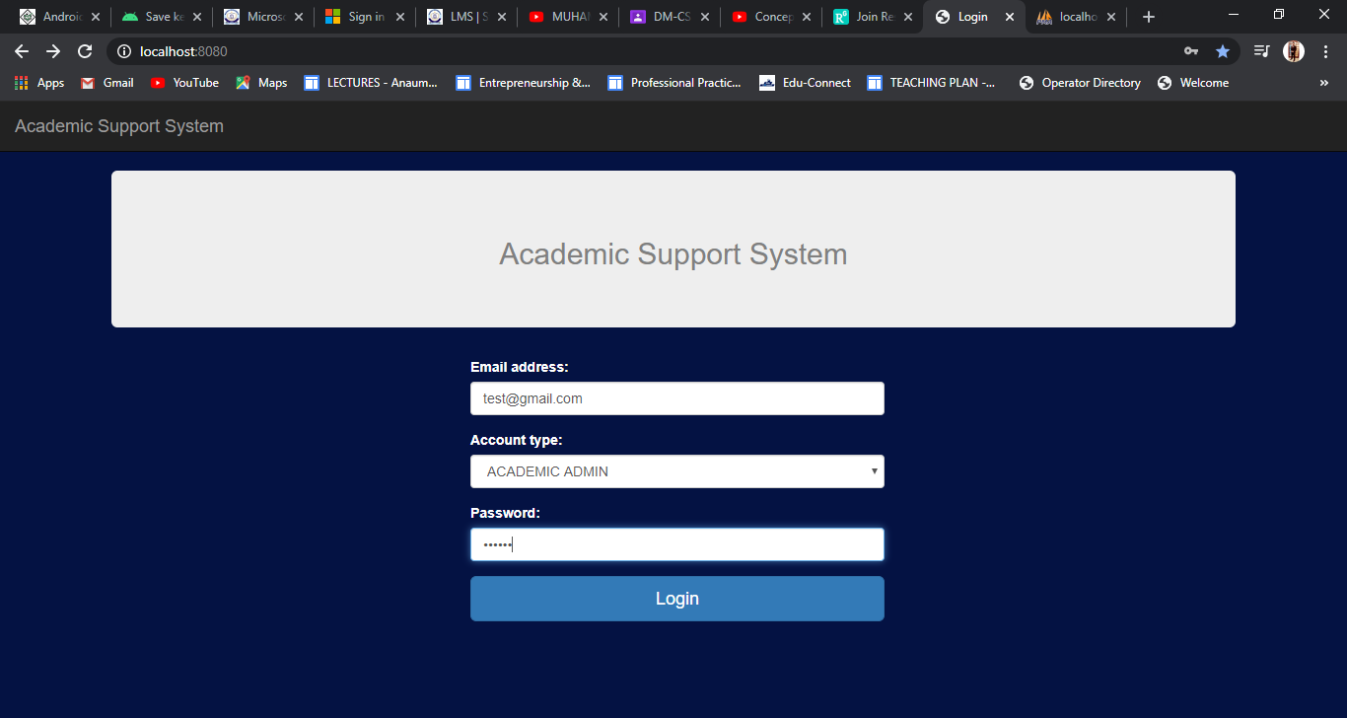

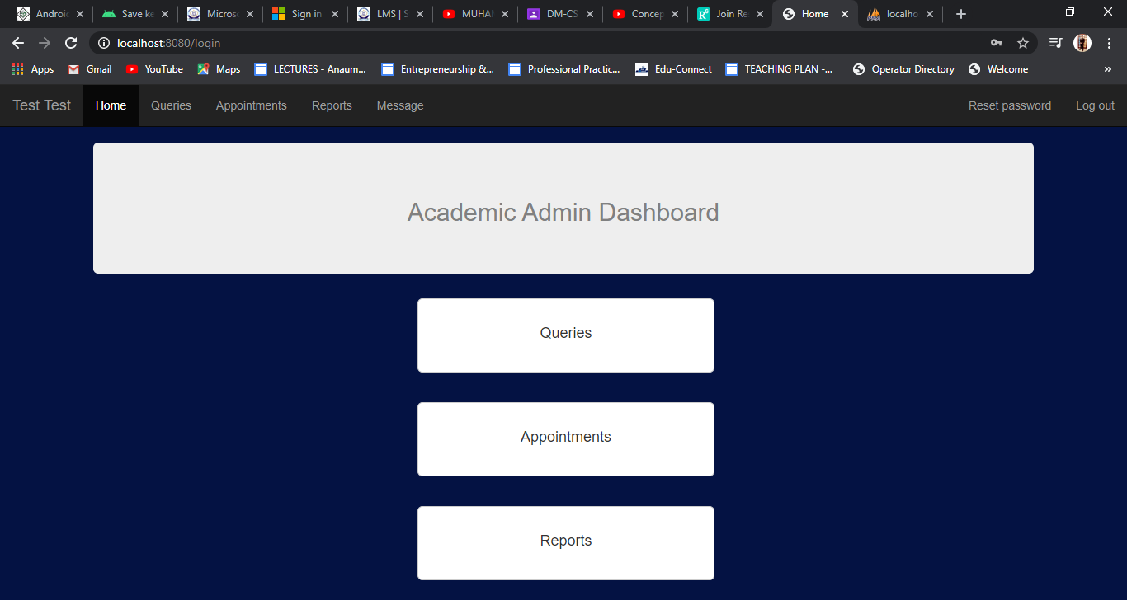

### User except academic admin tries to login:

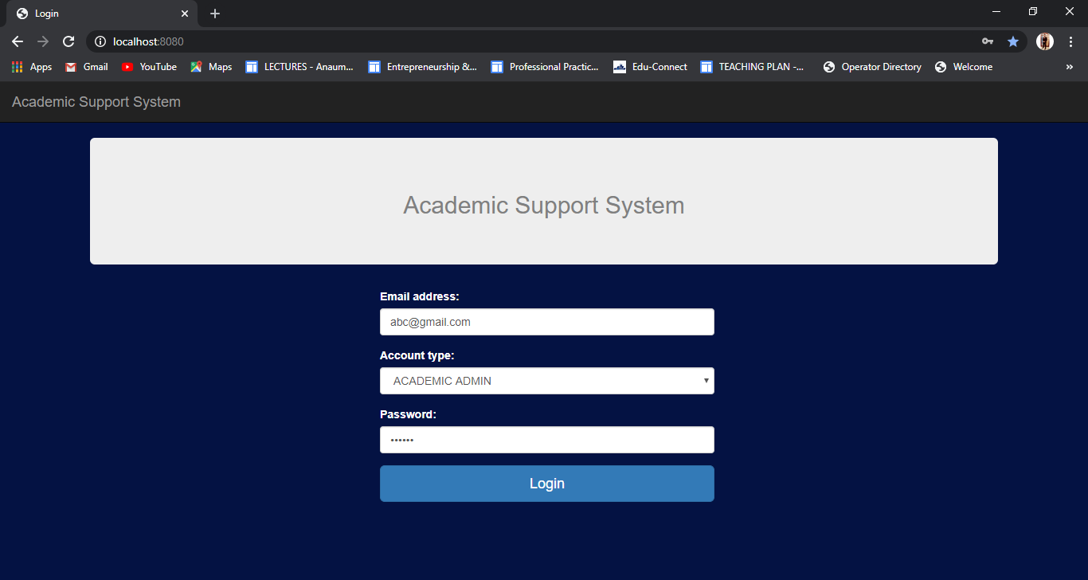

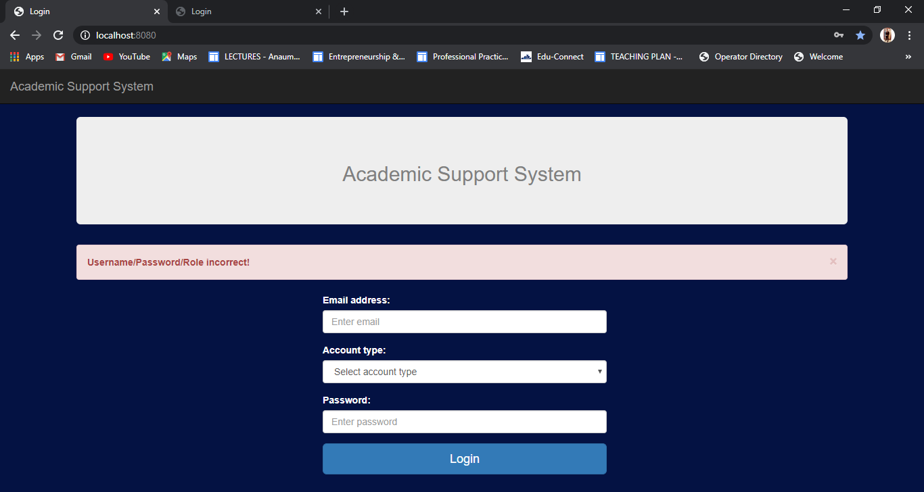

## 3) Test Student login:

|  |  |  |  |  |  |  |
| --- | --- | --- | --- | --- | --- | --- |
| ID | Scenario | Preconditions | Steps involved | Expected Result | Actual Result | Status |
| 1 | Student can login successfully | Student already have the email and password | Enter correct password and email.  Then click on Login button. | Student login to the system. | Student login to the system. | **Passed** |
| 2 | User except Student tries to login to the system | have the email or password of the admin account. | Enter invalid email or password.  Then click on Login button. | Username/Password/Role incorrect | Username/Password/Role incorrect | **Passed** |

### Student can login successfully

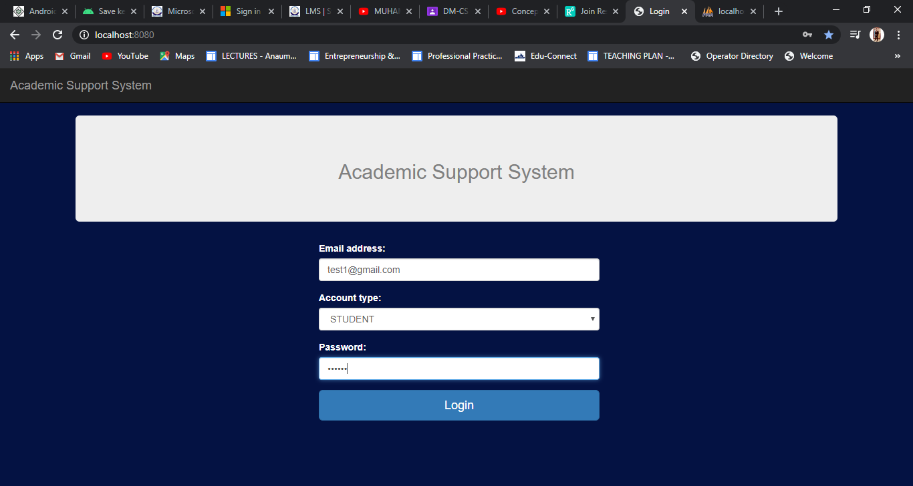

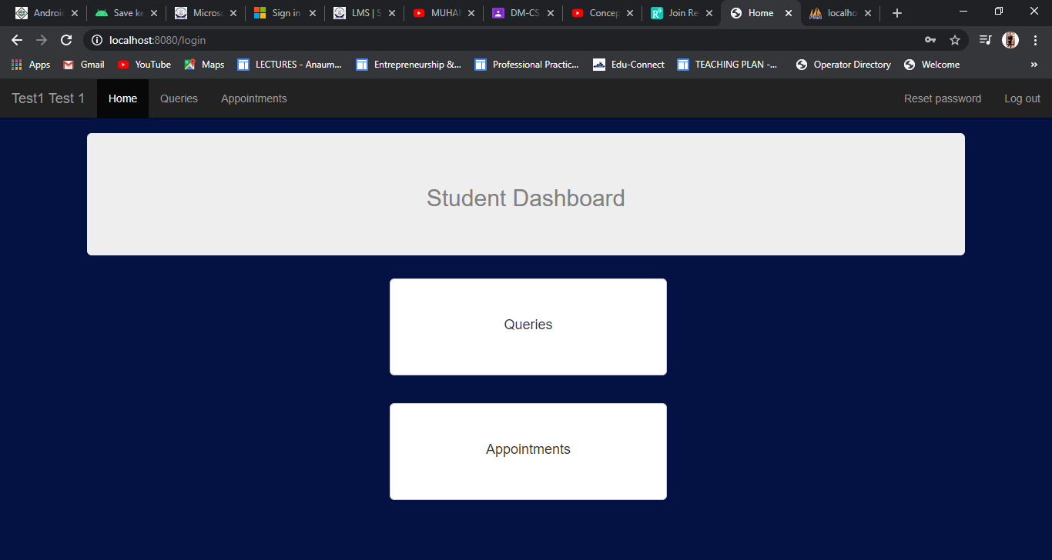

### User except Student tries to login

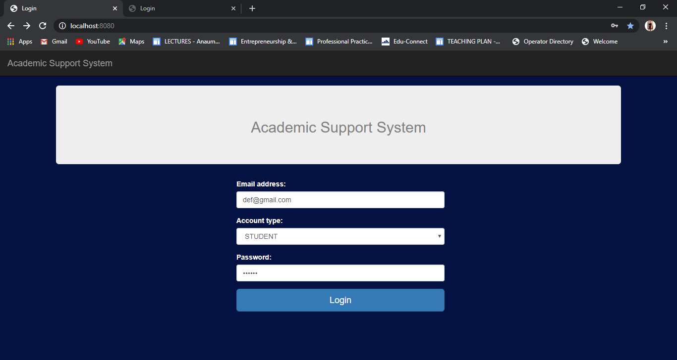

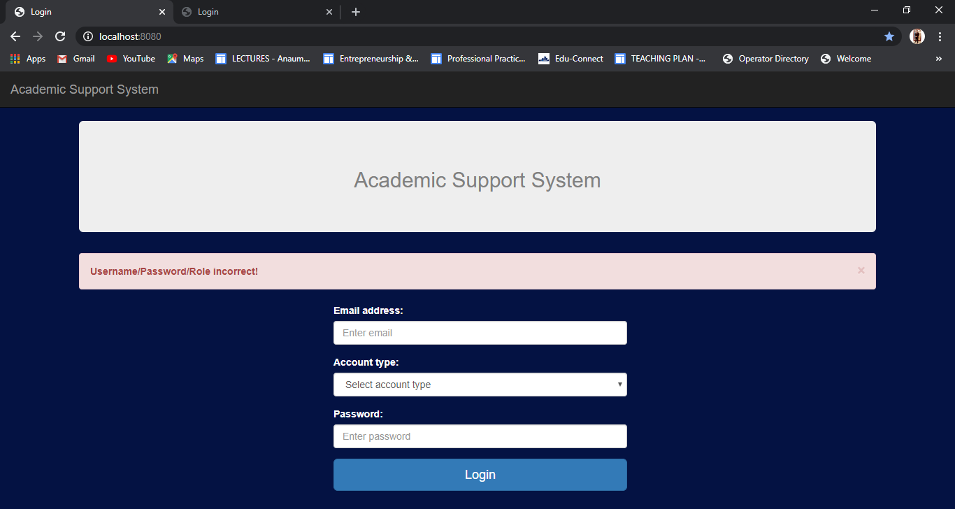

## 4) Test Users:

|  |  |  |  |  |  |  |
| --- | --- | --- | --- | --- | --- | --- |
| ID | Scenario | Preconditions | Steps involved | Expected Result | Actual Result | Status |
| 1 | Admin can view all the users | Admin is logged in to the admin dashboard. | Login ad admin.  Go to user’s page. | All Users visible to admin. | All Users visible to admin. | **Passed** |
| 2 | Admin can add a single user. | Admin is logged in to the admin dashboard. | Login as admin.  Add user details.  Click on the add button. | User created successfully. | User created successfully | **Passed** |
| 3 | Admin can add multiple users. | Admin is logged in to the admin dashboard. | Login as admin.  Select the csv file with proper multiple user details.  Click on the upload button. | User created successfully. | Username/Password/Role incorrect | **Passed** |
| 4 | Admin can delete a user | Admin is logged in to the admin dashboard. | Login as admin.  Click on delete button for a user in users table. | User deleted! | User deleted! | **Passed** |

### Admin can view all users

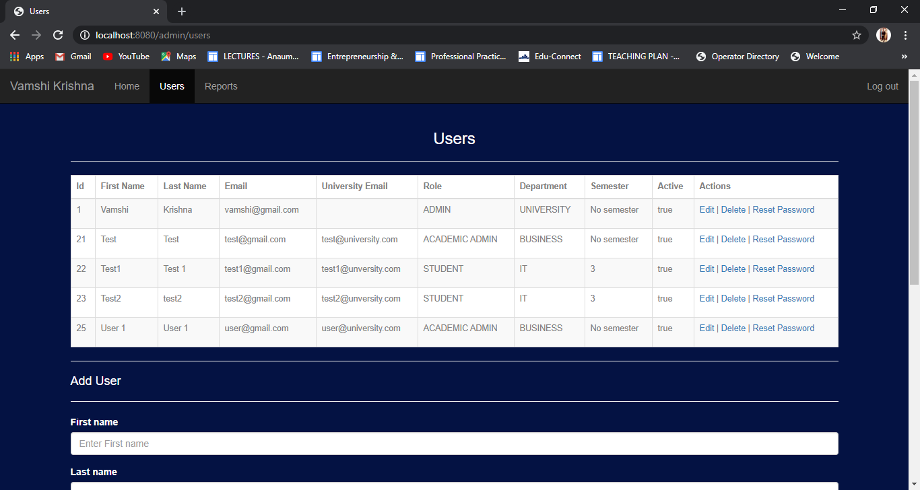

### Admin can add a single user

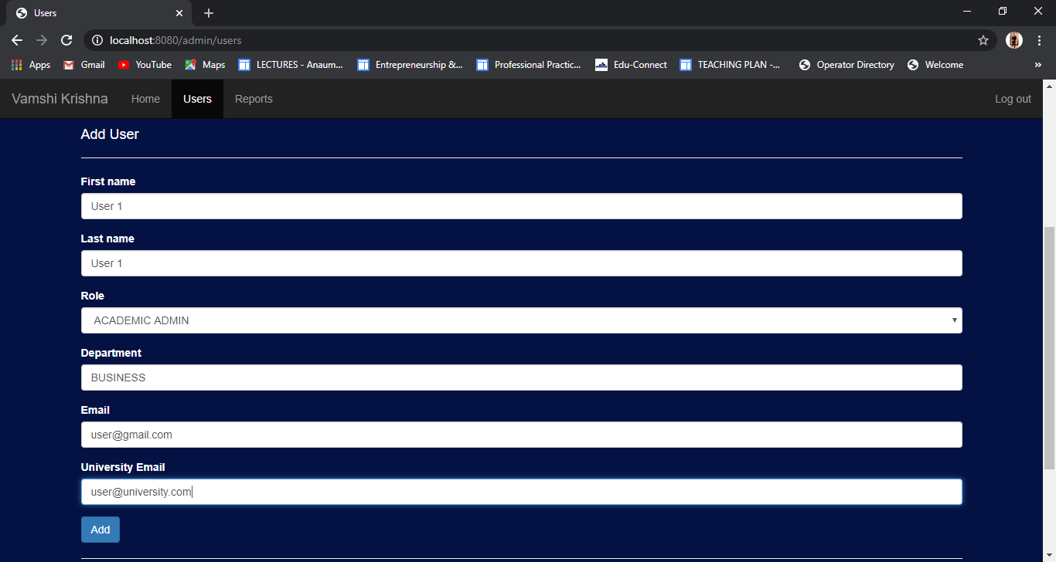

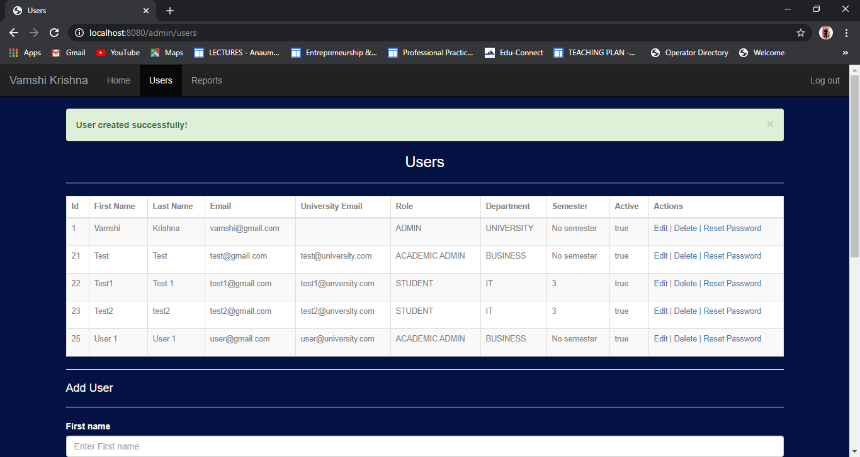

### Admin can add multiple users

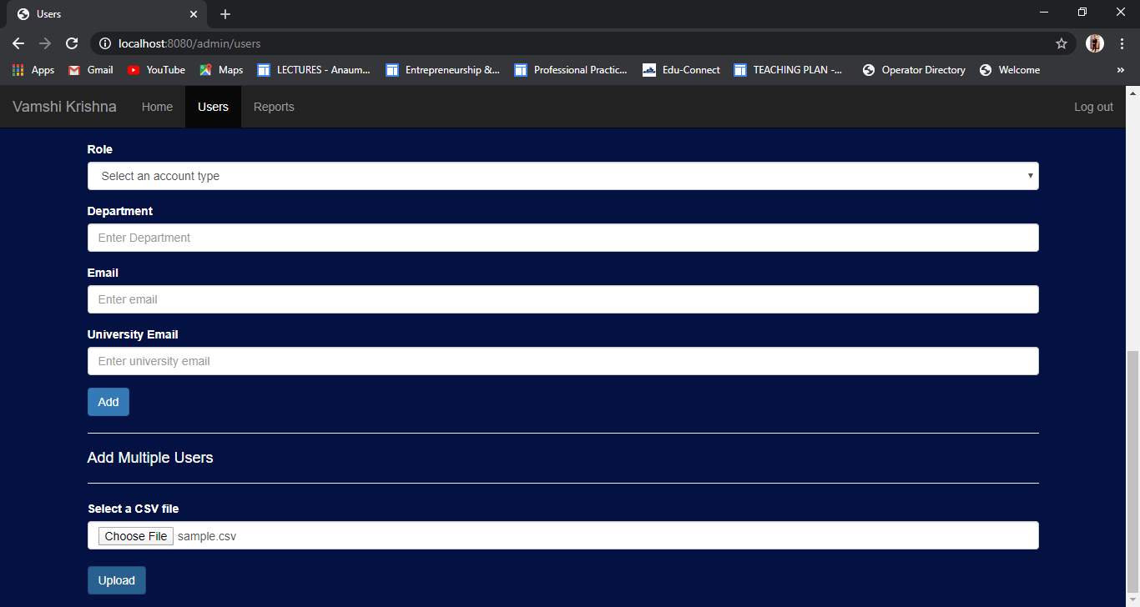



### Admin can delete users

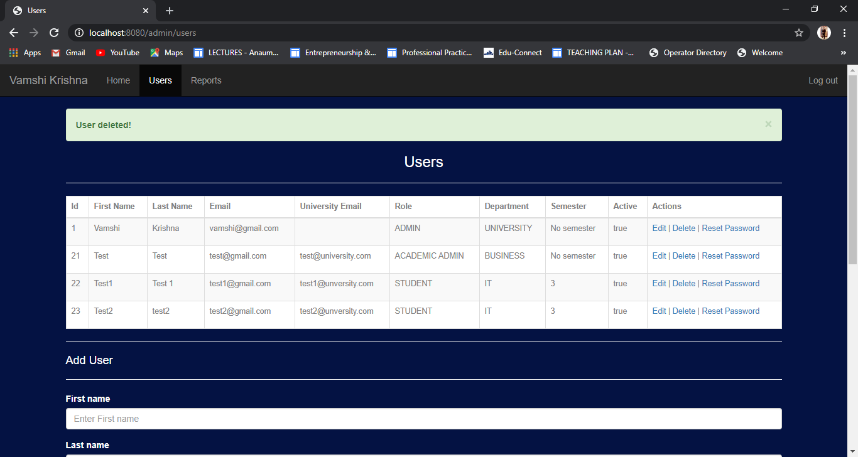

## 5) Test Admin Reports:

|  |  |  |  |  |  |  |
| --- | --- | --- | --- | --- | --- | --- |
| ID | Scenario | Preconditions | Steps involved | Expected Result | Actual Result | Status |
| 1 | Admin can view previous generated reports. | Admin is logged in to the system. | Login as admin to the system.  Go to Reports page. | Admin can view all reports. | Admin can view all reports. | **Passed** |
| 2 | Admin can generate monthly query report. | Admin is logged in to the system. | Login as admin to the system.  Select the semester, department and month.  Click on generate button. | Report generated successfully. | Report generated successfully | **Passed** |
| 3 | Admin can generate yearly query report. | Admin is logged in to the system. | Login as admin to the system.  Select the semester, department and year.  Click on generate button. | Report generated successfully. | Report generated successfully. | **Passed** |

### Admin can view previous generated reports

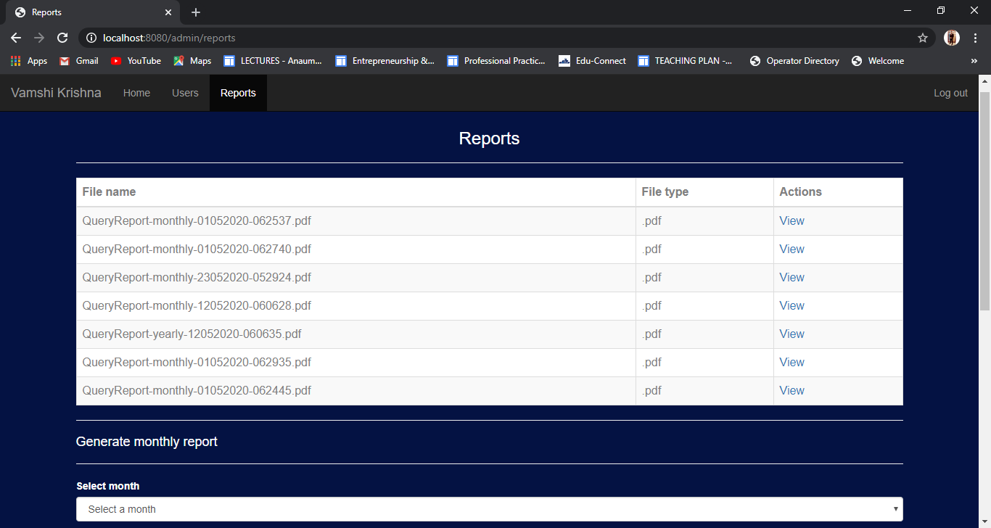

### Admin can generate monthly report

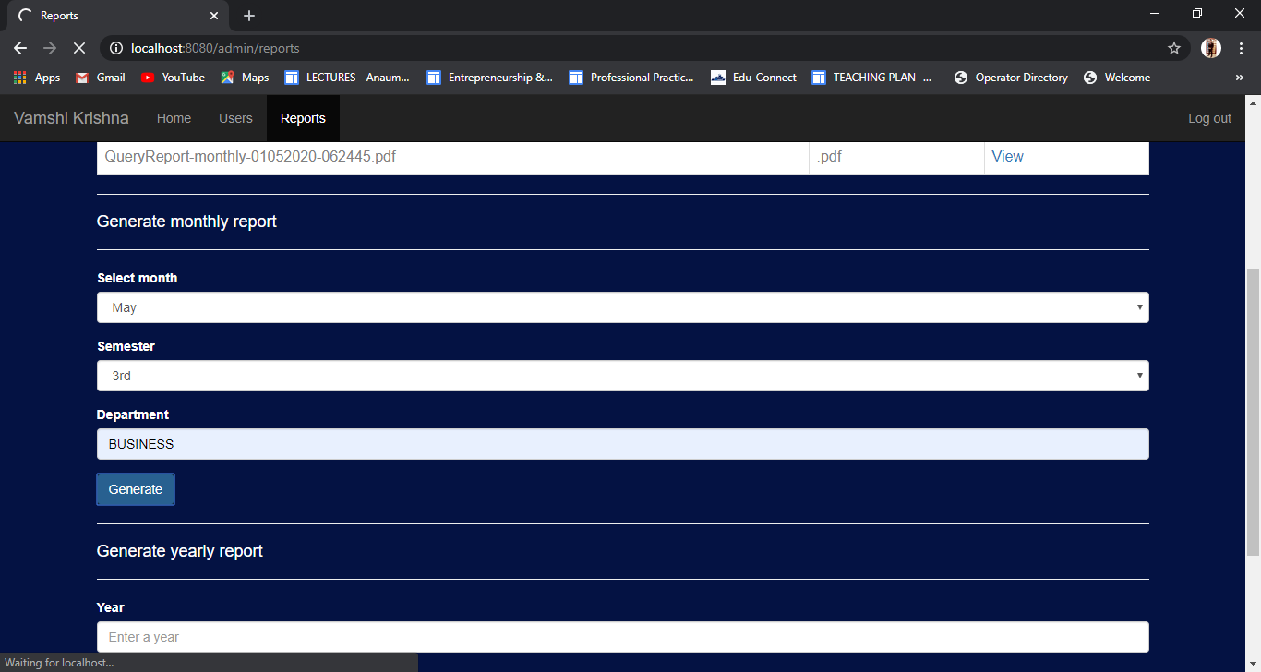

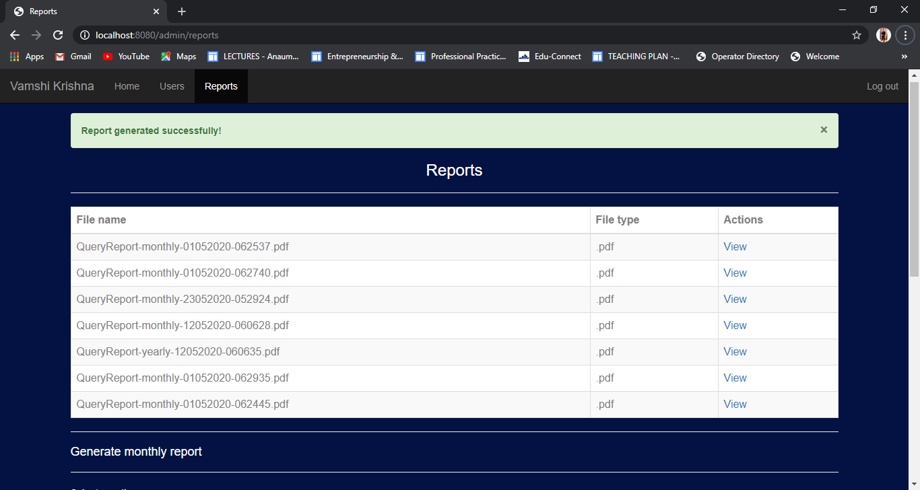

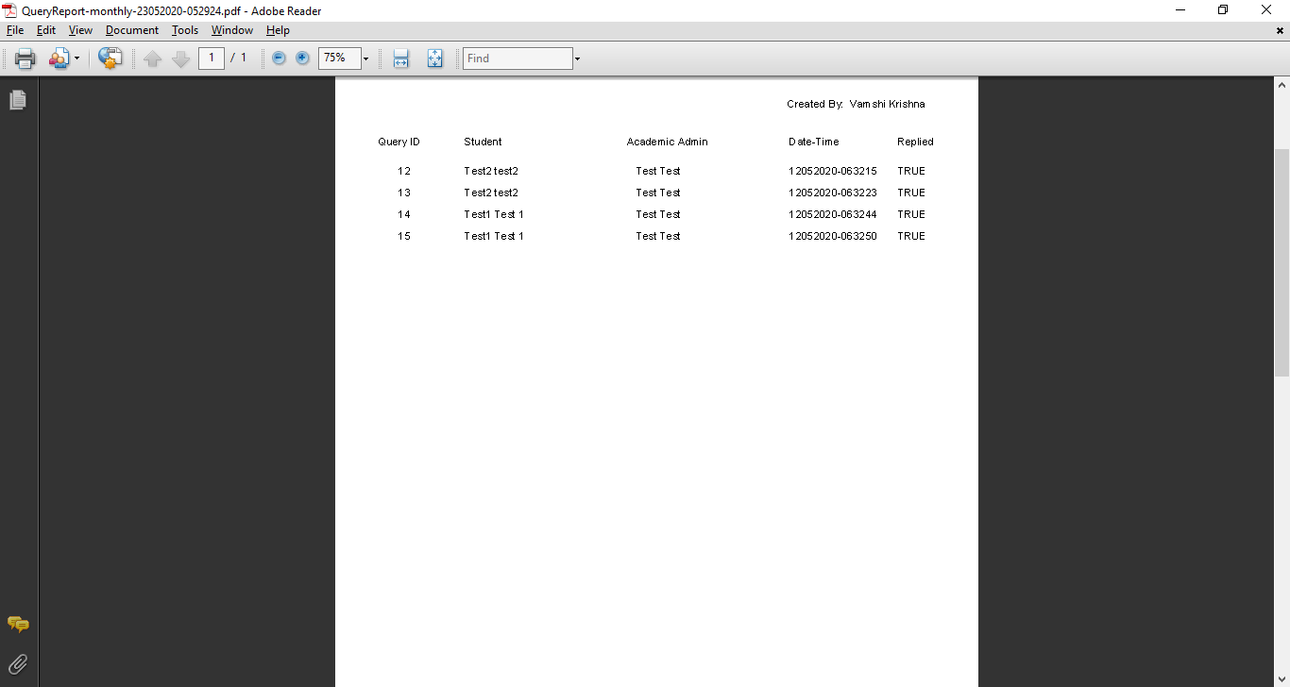

### Admin can generate yearly report

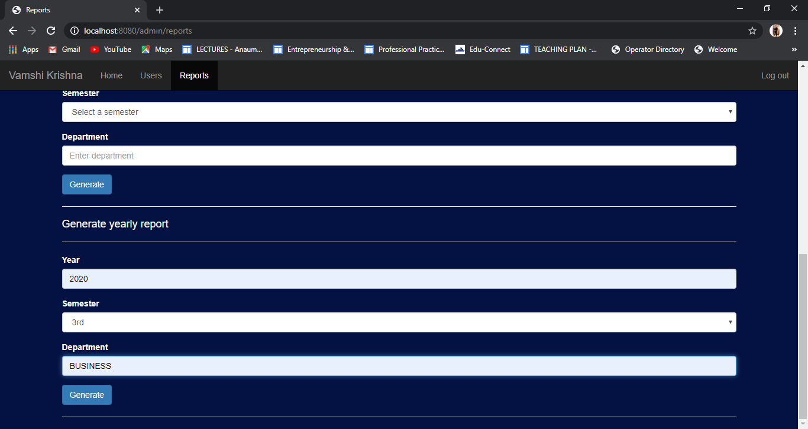

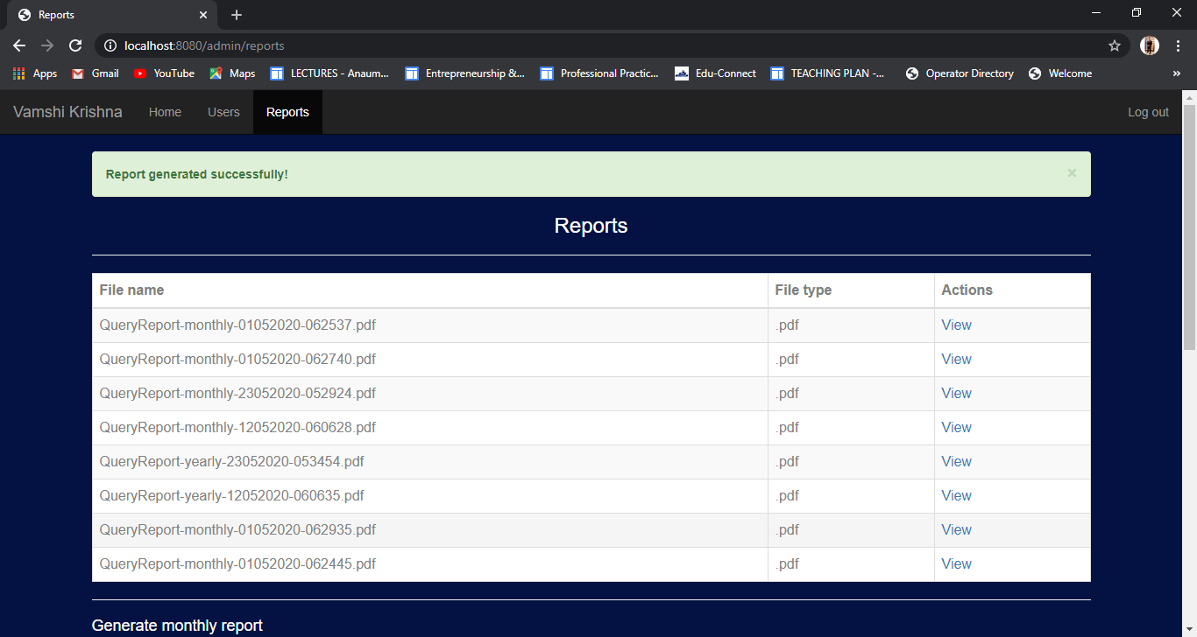

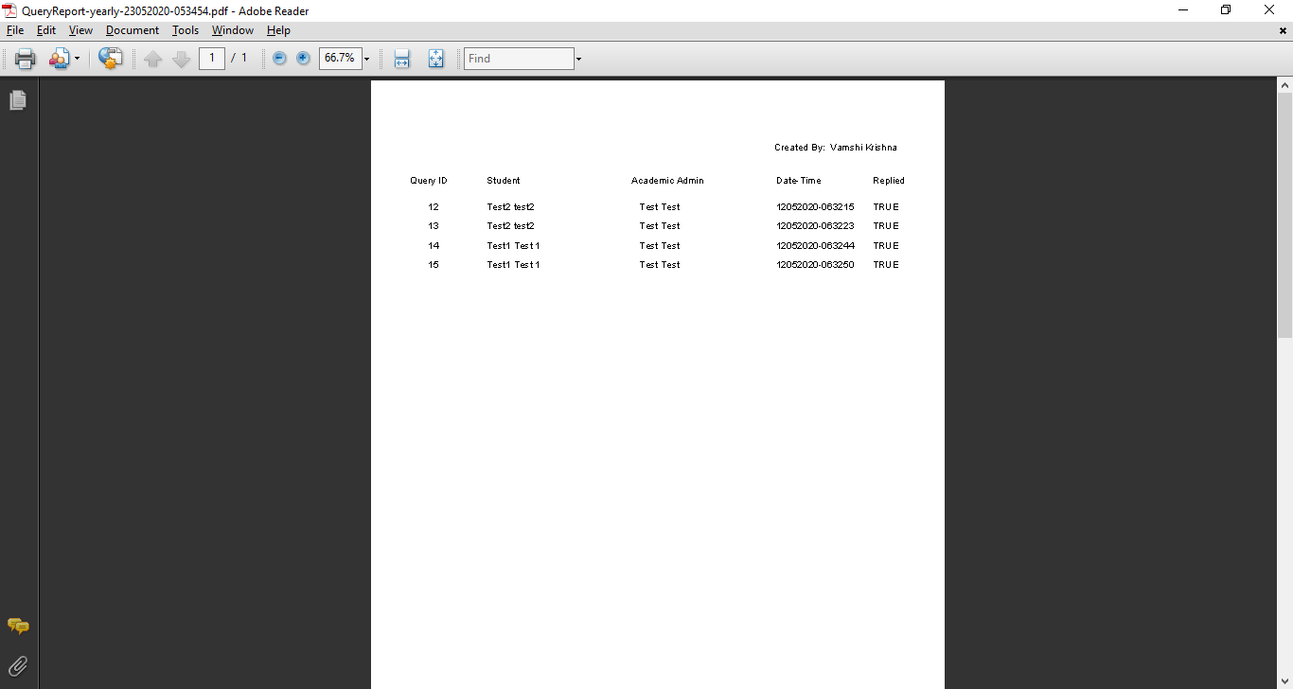

## 6) Test Academic Admin Queries:

|  |  |  |  |  |  |  |
| --- | --- | --- | --- | --- | --- | --- |
| ID | Scenario | Preconditions | Steps involved | Expected Result | Actual Result | Status |
| 1 | Academic admin can view all queries sent to them. | Academic admin is logged in to the system. | Login as academic admin to the system.  Go to Queries page. | Academic Admin can view all queries. | Academic Admin can view all queries. | **Passed** |
| 2 | Academic Admin can reply to queries. | Academic Admin is logged in to the system. | Login as admin to the system.  Go to Queries page.  Click on reply query button. | The query reply sent to the student successfully. | The query reply sent to the student successfully. | **Passed** |

### Academic admin can view all queries sent to them

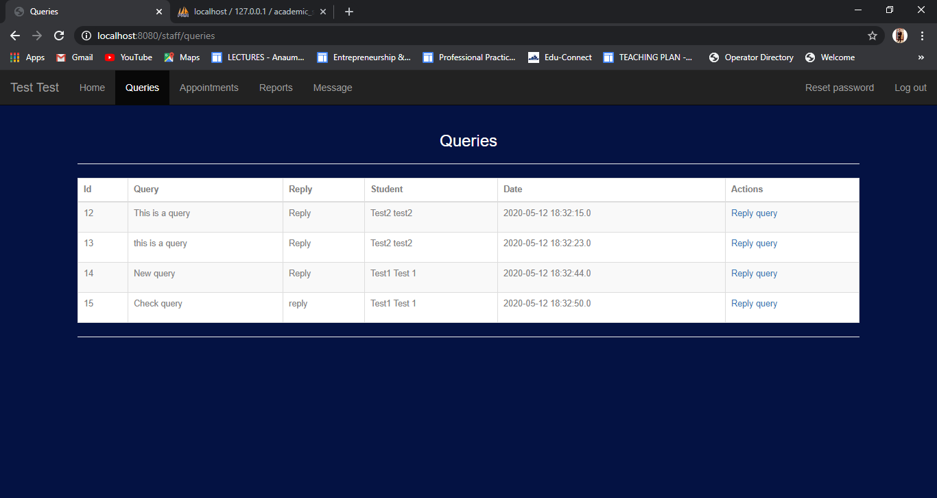

### Academic Admin can reply to queries

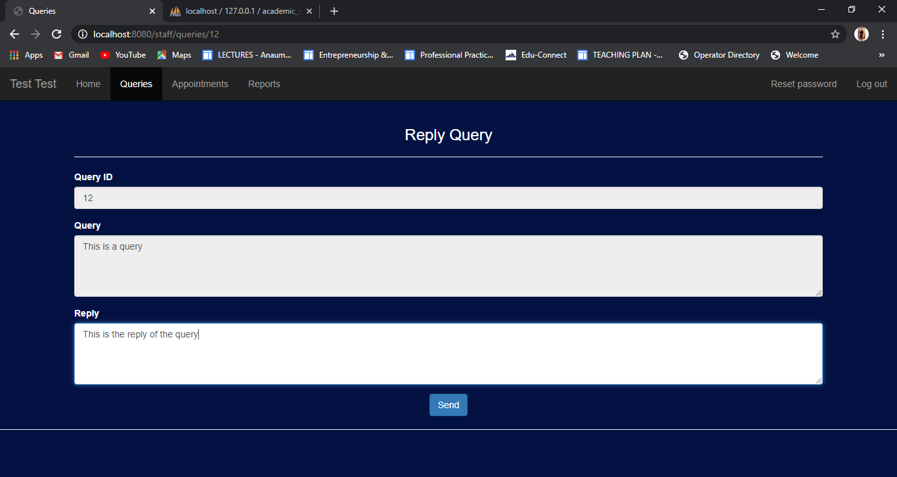

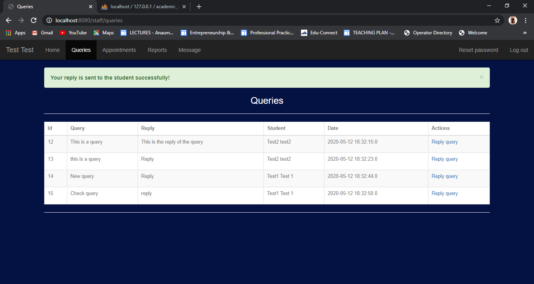

## 7) Test Academic Admin Appointments:

|  |  |  |  |  |  |  |
| --- | --- | --- | --- | --- | --- | --- |
| ID | Scenario | Preconditions | Steps involved | Expected Result | Actual Result | Status |
| 1 | Academic admin can view all appointment set by them. | Academic admin is logged in to the system. | Login as academic admin to the system.  Go to Appointments page. | Academic Admin can view all appointments. | Academic Admin can view all appointments. | **Passed** |
| 2 | Academic Admin can set an appointment for a student. | Academic Admin is logged in to the system. | Login as admin to the system.  Go to Appointments page.  Select the student, purpose of appointment, description and date.  Click on send button. | Appointment is set for the student. | Appointment is set for the student. | **Passed** |

### Academic admin can view all appointment set by them

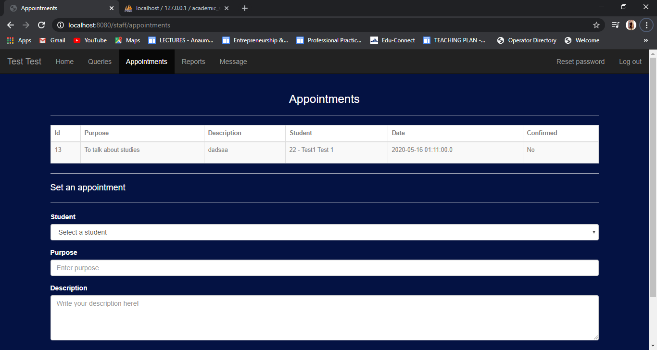

### Academic Admin can set an appointment for a student

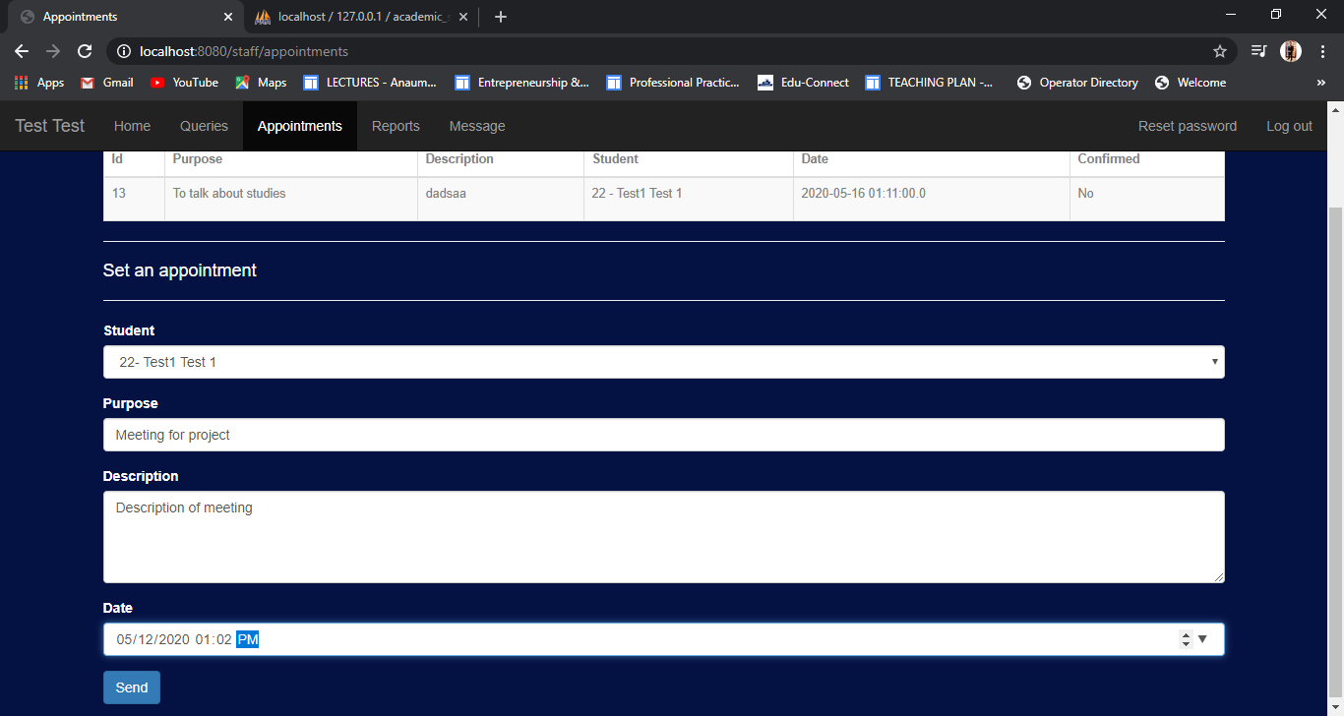

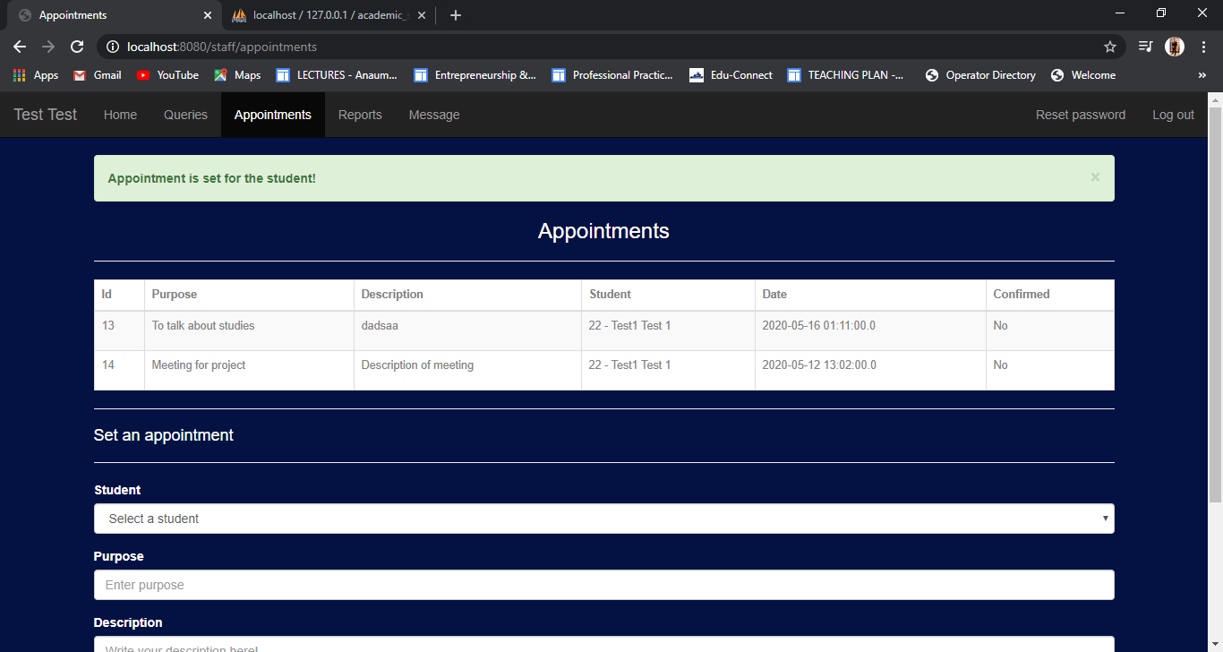

## 8) Test Academic Admin Reports:

|  |  |  |  |  |  |  |
| --- | --- | --- | --- | --- | --- | --- |
| ID | Scenario | Preconditions | Steps involved | Expected Result | Actual Result | Status |
| 1 | Academic Admin can view previous generated reports. | Academic Admin is logged in to the system. | Login as academic admin to the system.  Go to Reports page. | Academic Admin can view all reports. | Academic Admin can view all reports. | **Passed** |
| 2 | Academic Admin can generate monthly query report. | Academic Admin is logged in to the system. | Login as academic admin to the system.  Select the semester, department and month.  Click on generate button. | Report generated successfully. | Report generated successfully | **Passed** |
| 3 | Academic Admin can generate yearly query report. | Academic Admin is logged in to the system. | Login as academic admin to the system.  Select the semester, department and year.  Click on generate button. | Report generated successfully. | Report generated successfully. | **Passed** |

### Academic Admin can view previous generated reports

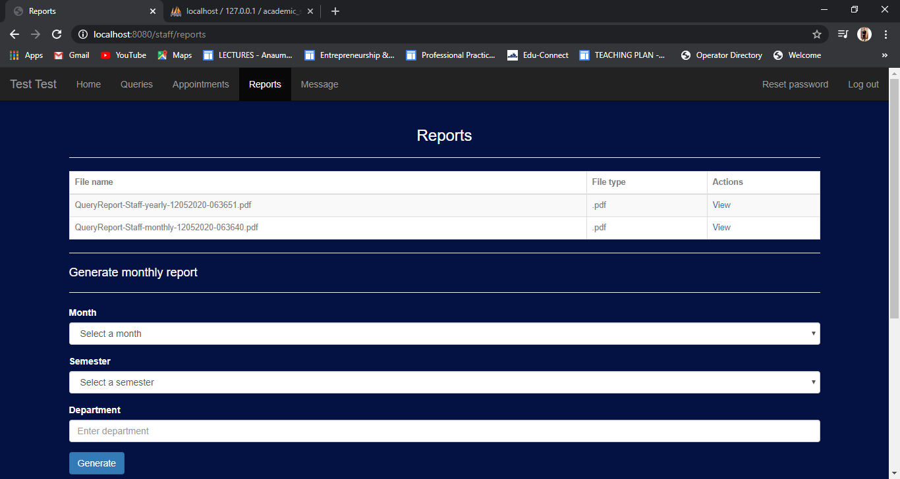

### Academic Admin can generate monthly report



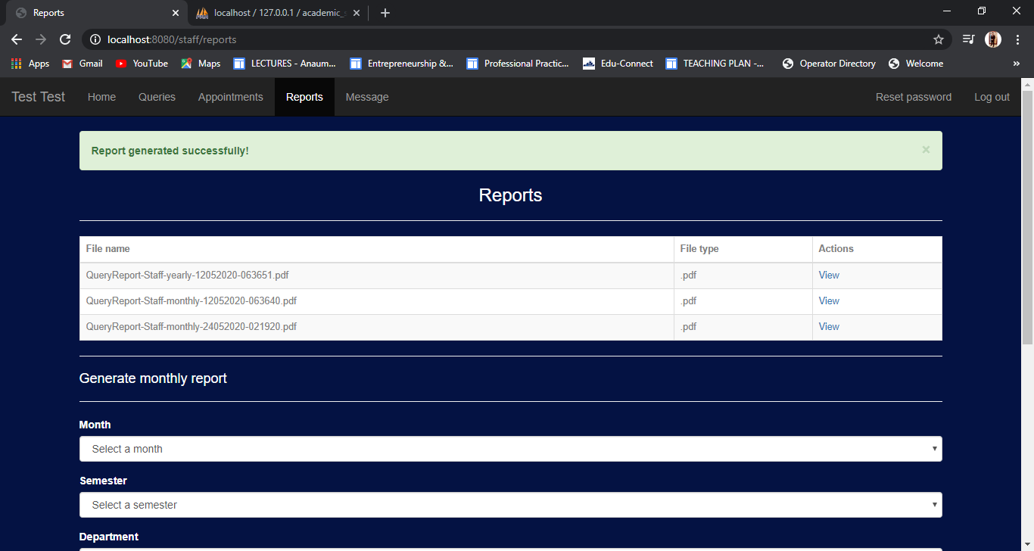

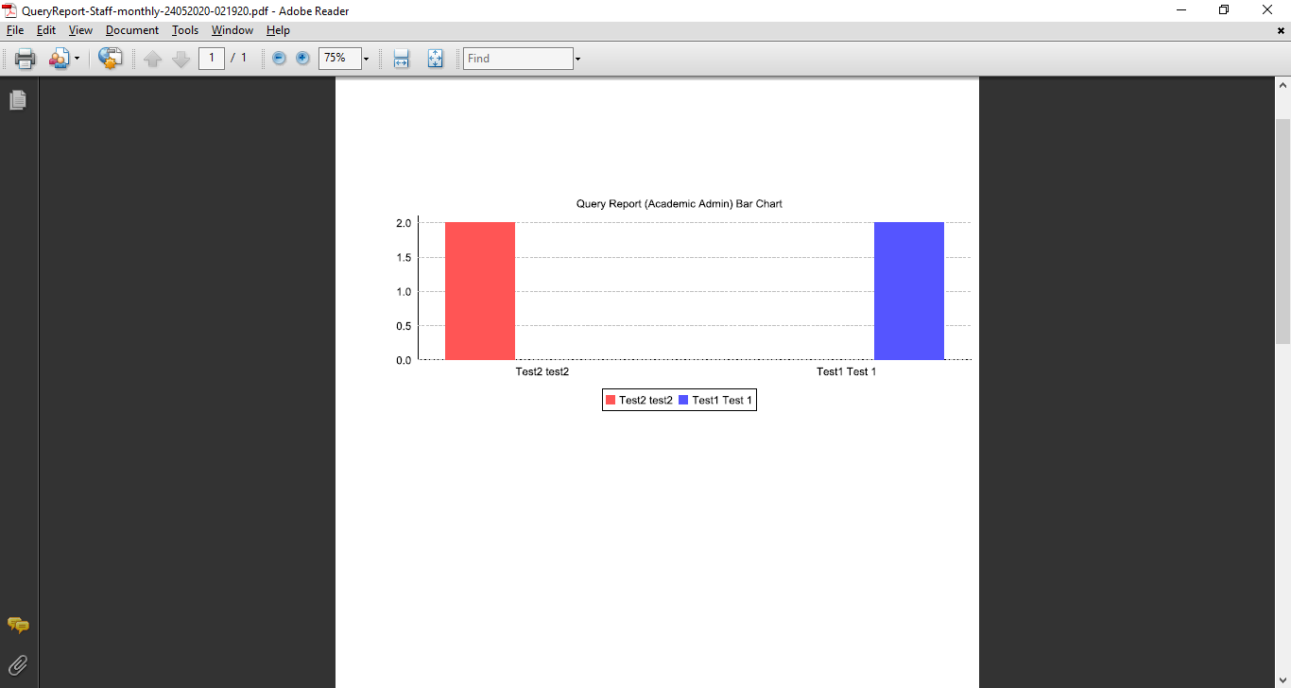

### Academic Admin can generate yearly report





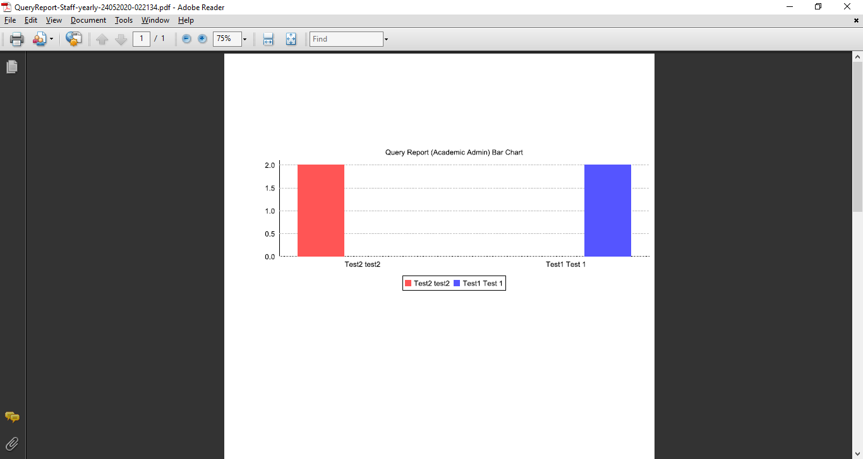

## 8) Test Academic Admin Message:

|  |  |  |  |  |  |  |
| --- | --- | --- | --- | --- | --- | --- |
| ID | Scenario | Preconditions | Steps involved | Expected Result | Actual Result | Status |
| 1 | Academic Admin can send message to the student. | Academic Admin is logged in to the system. | Login as academic admin to the system.  Go to Message page.  Select student.  Write a subject and message and click on send button. | Message sent successfully. | Message sent successfully. | **Passed** |

### Academic Admin can send message to the student

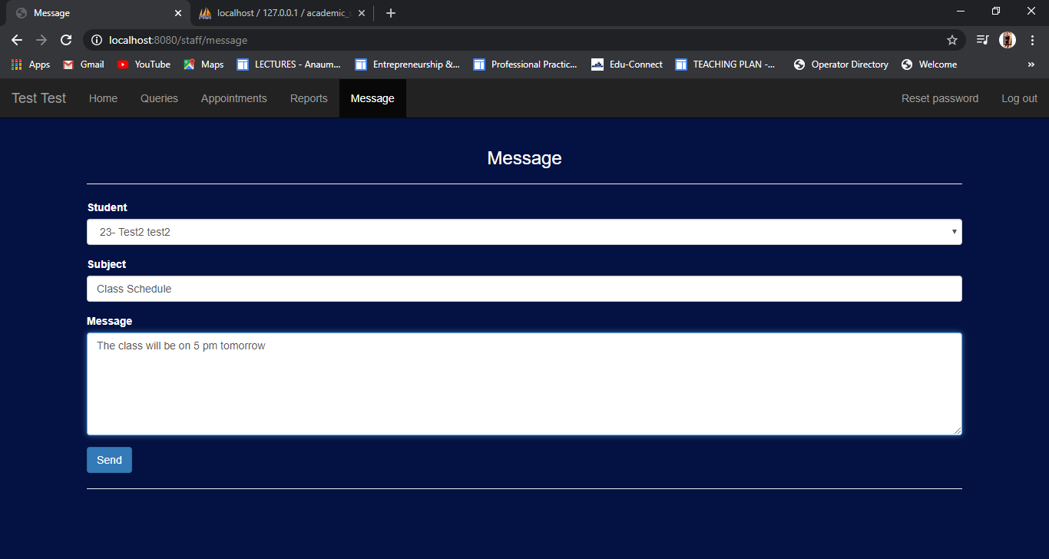

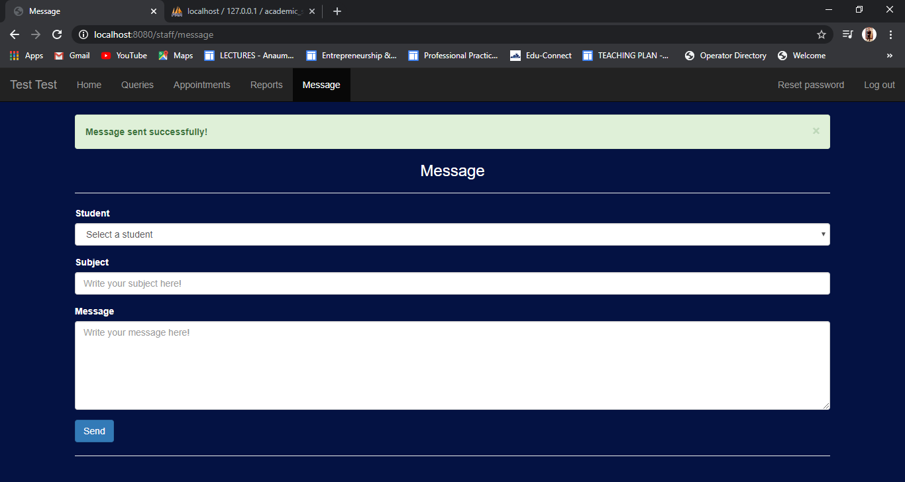

## 9) Test Student Queries:

|  |  |  |  |  |  |  |
| --- | --- | --- | --- | --- | --- | --- |
| ID | Scenario | Preconditions | Steps involved | Expected Result | Actual Result | Status |
| 1 | Student can view all the queries and their replies sent by them. | Student is logged in to the system. | Login as student in the system.  Go to the Queries page. | Student can view all the queries and replies. | Student can view all the queries and replies. | **Passed** |
| 2 | Student can send a query to the academic admin | Student is logged in to the system. | Login as student in the system.  Go to the Queries page.  Select academic admin.  Write query and click on send button. | Query sent successfully. | Query sent successfully. | **Passed** |

### Student can view all the queries and their replies sent by them.

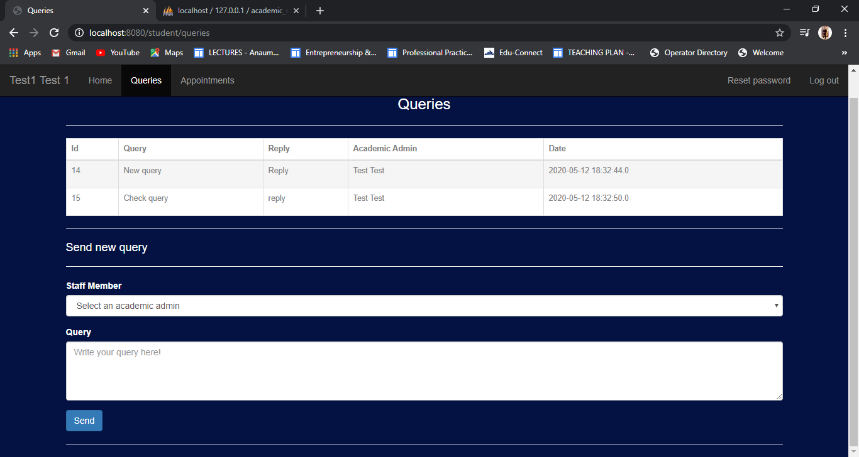

### Student can send a query to the academic admin

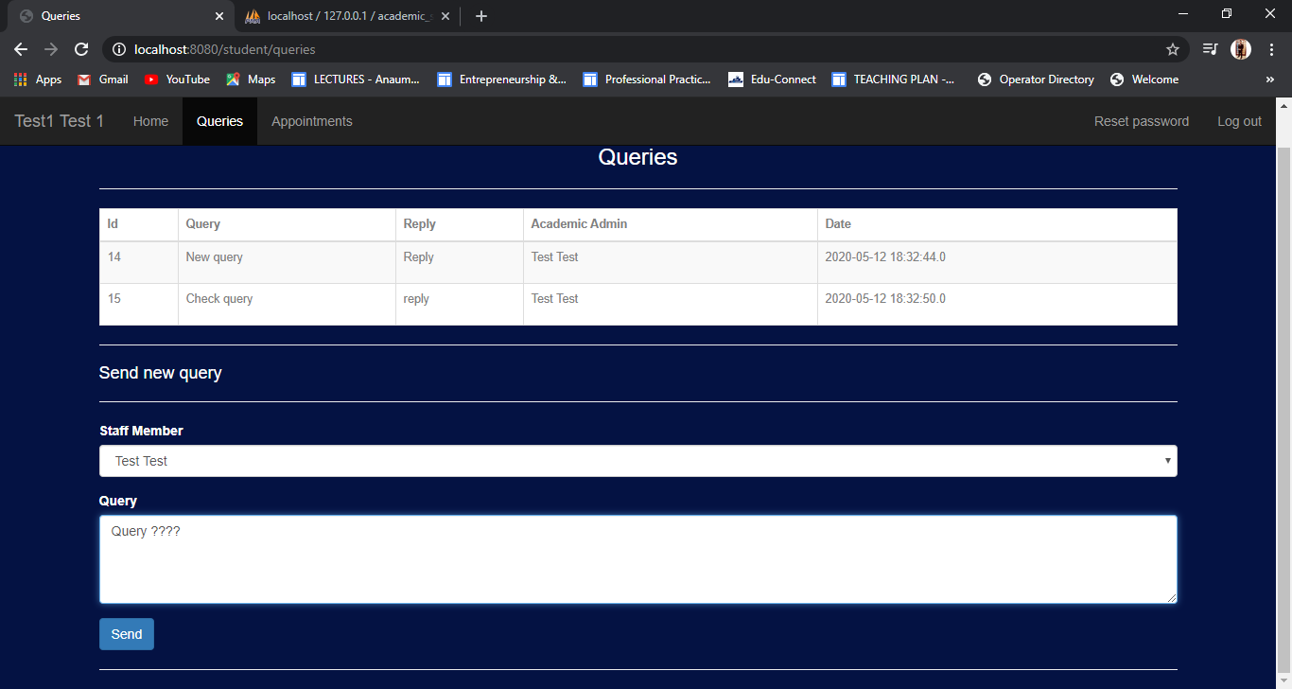

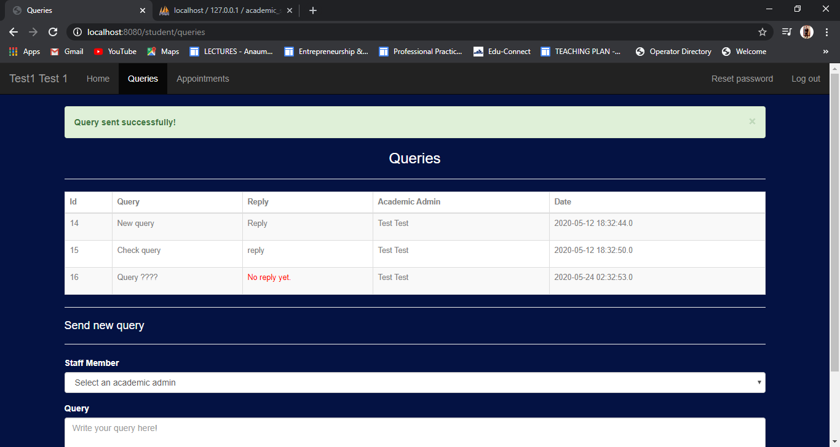

## 10) Test Student Appointments:

|  |  |  |  |  |  |  |
| --- | --- | --- | --- | --- | --- | --- |
| ID | Scenario | Preconditions | Steps involved | Expected Result | Actual Result | Status |
| 1 | Student can view all the appointments | Student is logged in to the system. | Login as student in the system.  Go to the Appointments page. | Student can view all the appointments. | Student can view all the appointments. | **Passed** |
| 2 | Student can confirm an appointment | Student is logged in to the system. | Login as student in the system.  Go to the Appointments page.  Click on Confirm appointment. | Appointment confirmed successfully. | Appointment confirmed successfully. | **Passed** |

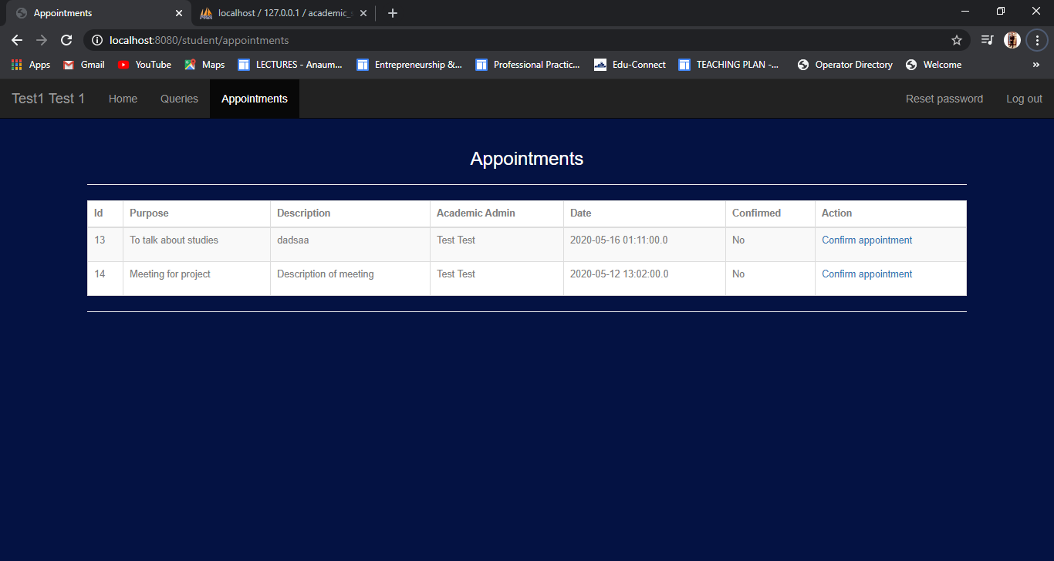

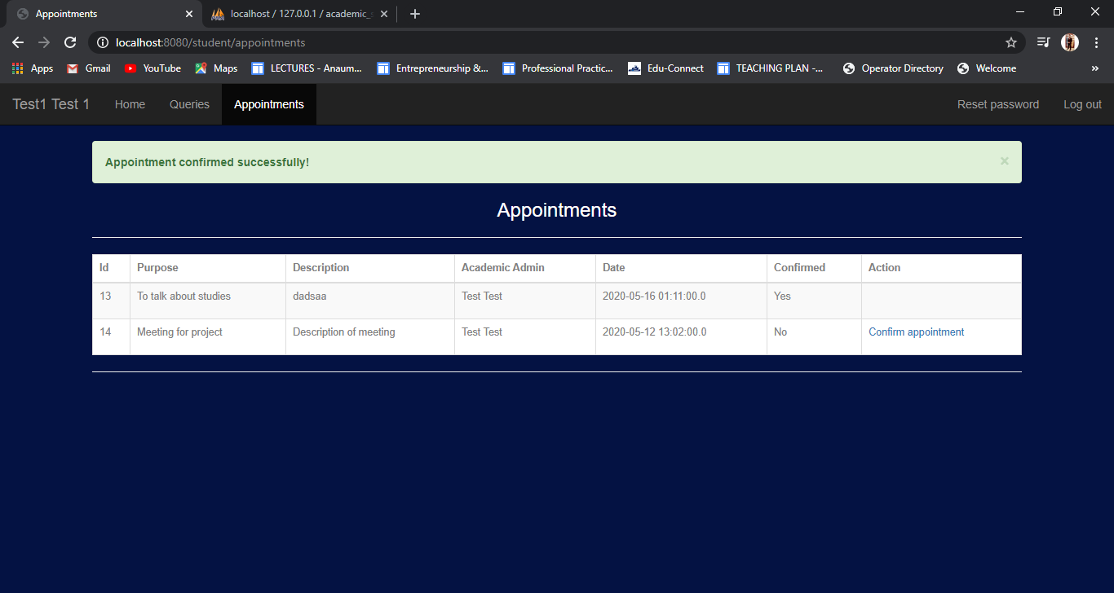

## 10) Test Reset Password:

|  |  |  |  |  |  |  |
| --- | --- | --- | --- | --- | --- | --- |
| ID | Scenario | Preconditions | Steps involved | Expected Result | Actual Result | Status |
| 1 | Admin can reset password of any user. | Admin is logged in to the system. | Login as admin in the system.  Go to Users page.  Click on reset password.  Provide the new password.  Click on reset password button. | User password changed. | User password changed. | **Passed** |
| 2 | Academic admin can reset their own password. | Academic admin is logged in to the system. | Login as academic admin in the system.  Click on Reset password.  Enter new password.  Click on reset password button. | User password changed. | User password changed. | **Passed** |
| 3 | Student can reset their own password. | Student is logged in to the system. | Login as student in the system.  Click on Reset password.  Enter new password.  Click on reset password button. | User password changed. | User password changed. | **Passed** |

### Admin can reset password of any user

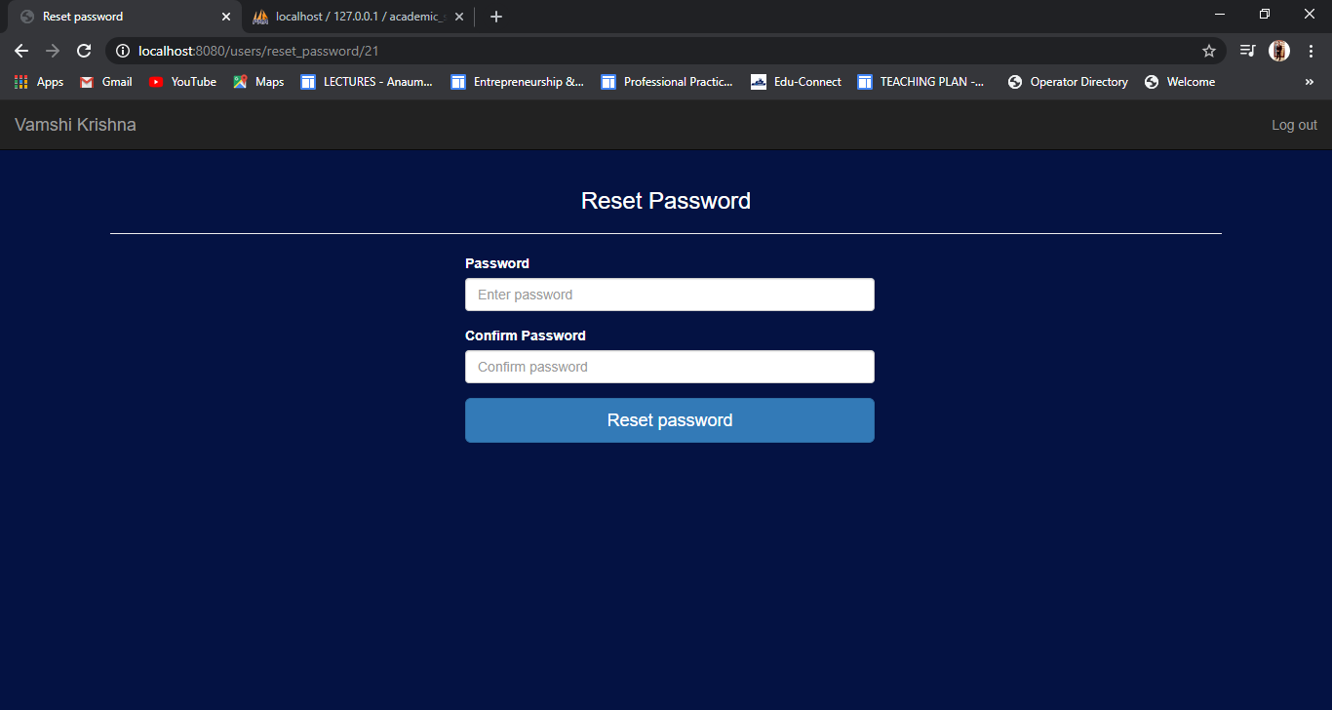

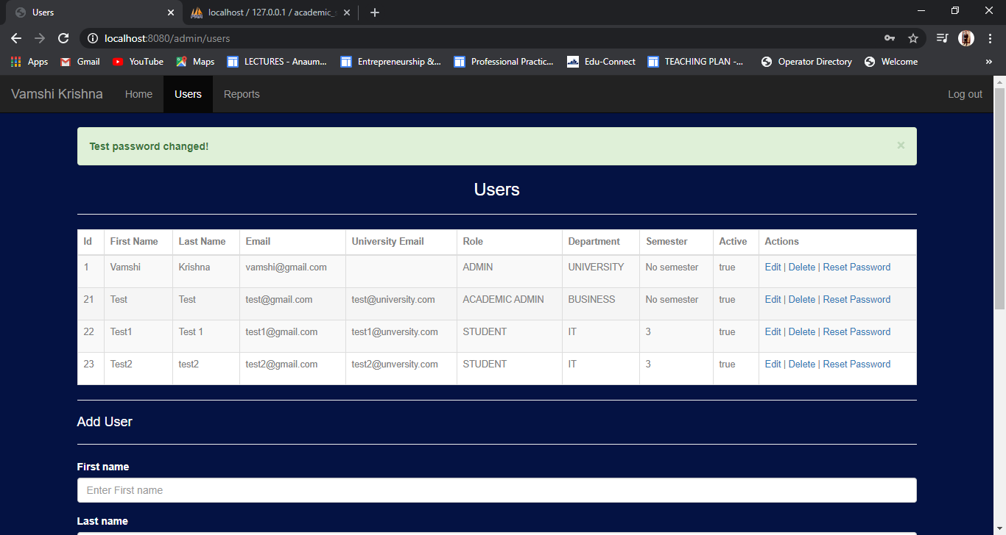

### Academic admin can reset their own password

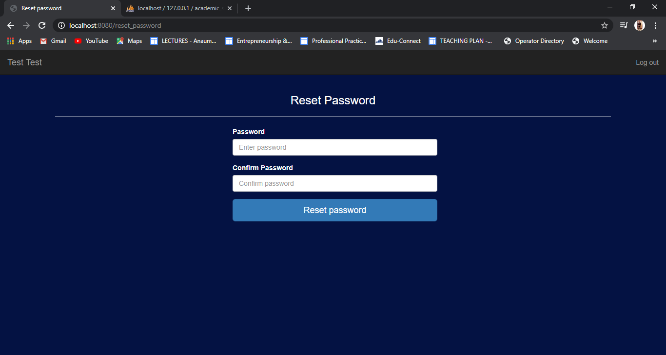

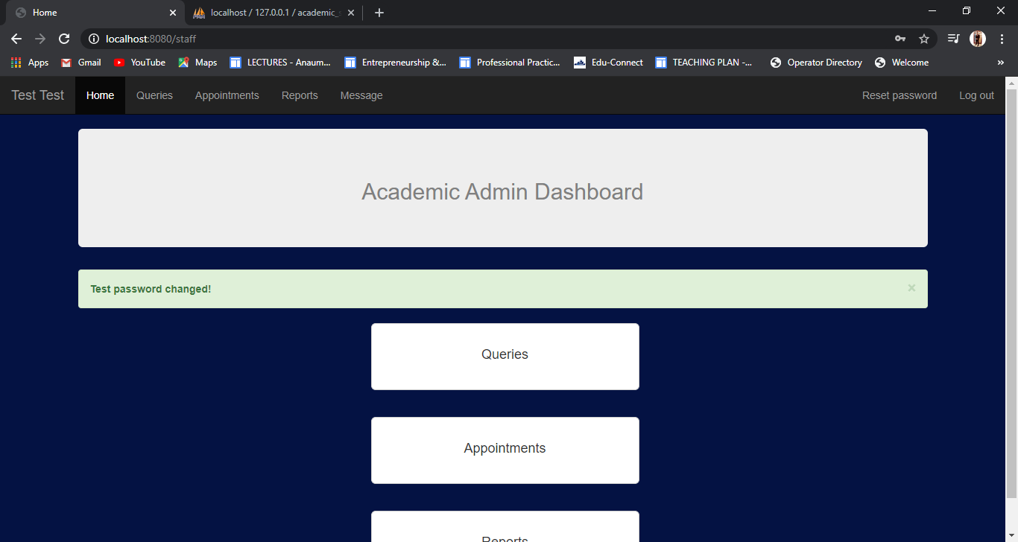

### Student can reset their own password

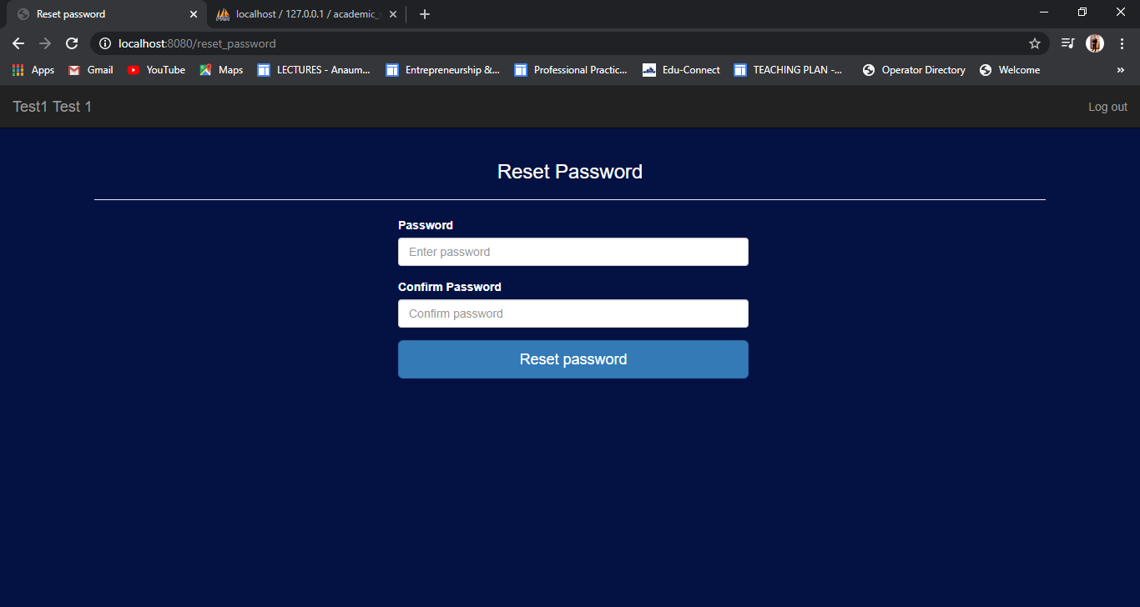

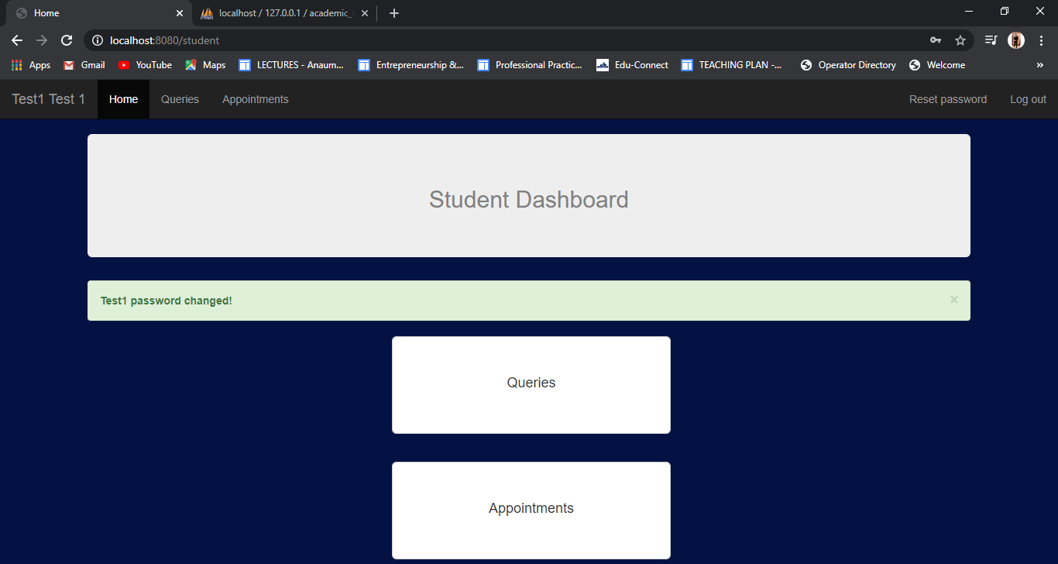

# **Summary of Findings, Limitations, and Recommendations**

## **Applications of the Admin User:**

* Admin can sign in/ sign out of the system.
* Admin can add/remove users in bulk or one at a time.
* Admin can reset passwords.
* Admin can generate /view reports.

## **Applications of the Academic Admin User:**

* Academic Admin can sign/ sign out of system.
* Academic Admin can reset their passwords.
* Academic Admin can reply to students.
* Academic Admin can set appointments for students.
* Academic Admin can view reports in form of graphic charts.
* Academic Admin can generate monthly/weekly reports.

## **Applications of Student User:**

* Students can sign in / sign out of the systems.
* Students can reset their own passwords
* Students can send queries.
* Students can see replies to their queries.
* Student can confirm their appointments.

## **Limitations**

* The website is accessible via an internet connection.
* The website will need MySQL and other systems connected to a single network to get the functionality.
* Only the admin user can remove or add user.
* The application is communicating with the user by means of emails too.
* When a query or the reply to that query gets posted or appointment set, the user receives an email too regarding the notification that a reply or something has been posted. This keeps in check that if the user doesn’t open the ports, he/she still receives a notification on email too.

## **Improvements:**

The website offers every single required element in great quality and an engaging structure. In any case, due to the constrained time and the attention on conveying a completed product on schedule, there is still space for improvement and the usage of additional features.

# **Conclusion:**

Hence this report shows the development process of the Academic Support System, its procedures from requirement gathering to the final product. Why and for what reason the agile development was selected has also been discussed and the admin, users and stakeholders were identified.

Furthermore, development phases of the product and features of the project were explained in detail with screenshots. The test cases were also shown telling that the product works as it was needed to be by far. The final product is a web-based application that we hope will lessen the communication gaps between the students and academic admin and will increase the overall productivity of students with better resolving of students ‘problems and queries.

# **References:**

[1] K. Mir, “Design and Development of Online Student Support System,” *Pak. J. Distance Online Learn.*, vol. 3, pp. 1–8, Jul. 2017.

[2] B. L. Stewart, C. E. Goodson, S. L. Miertschin, M. L. Norwood, and S. Ezell, “Online Student Support Services: A Case Based on Quality Frameworks,” vol. 9, no. 2, p. 14, 2013.

[3] M. Britto and S. Rush, “DEVELOPING AND IMPLEMENTING COMPREHENSIVE STUDENT SUPPORT SERVICES FOR ONLINE STUDENTS,” *Online Learn.*, vol. 17, no. 1, Jan. 2013, doi: 10.24059/olj.v17i1.313.

[4] A. Cox and S. Emmott, “A survey of UK university web management: staffing, systems and issues,” *Campus-Wide Inf. Syst.*, vol. 24, no. 5, pp. 308–330, Jan. 2007, doi: 10.1108/10650740710835742.

[5] A. A. Khan and S. A. Khader, “An Approach for Externalization of Expert Tacit Knowledge Using a Query Management System in an E-Learning Environment,” *Int. Rev. Res. Open Distrib. Learn.*, vol. 15, no. 6, pp. 257–274, 2014, doi: https://doi.org/10.19173/irrodl.v15i6.1935.

[6] E. A. Afify and M. A. Kadry, “Electronic-Customer Complaint Management System (E-CCMS) – a Generic Approach,” *Int. J. Adv. Netw. Appl.*, vol. 11, no. 01, pp. 4125–4141, 2019, doi: 10.35444/IJANA.2019.11011.

[7] D. Hart and N. Coates, “International student complaint behaviour: Understanding how East-Asian business and management students respond to dissatisfaction during their university experience,” *Int. J. Manag. Educ.*, vol. 9, no. 4, pp. 57–66, 2011.

[8] “10 Strategies for Strengthening Academic and Social Support | Getting Smart.” https://www.gettingsmart.com/2017/05/10-strategies-for-strengthening-academic-and-social-support/ (accessed May 23, 2020).

[9] “What’s the role of student affairs and academic support staff when most students aren’t on campus? (opinion).” https://www.insidehighered.com/advice/2020/04/07/whats-role-student-affairs-and-academic-support-staff-when-most-students-arent (accessed May 23, 2020).

[10] “What’s the role of student affairs and academic support staff when most students aren’t on campus? (opinion).” https://www.insidehighered.com/advice/2020/04/07/whats-role-student-affairs-and-academic-support-staff-when-most-students-arent (accessed May 23, 2020).

[11] “Academic Support Services - Current Students - University of Idaho.” https://www.uidaho.edu/current-students/academic-support (accessed May 23, 2020).

[12] “Academic Support System,” *Pacific University*, Mar. 11, 2014. https://www.pacificu.edu/about/pacific-directory/offices-departments/enrollment-management-student-affairs/parent-support/academic-support-system (accessed May 23, 2020).

[13] G. S. Partnership, “Academic Support Definition,” *The Glossary of Education Reform*, May 15, 2013. https://www.edglossary.org/academic-support/ (accessed May 23, 2020).

[14] “Academic Support Services | Dartmouth Student Affairs.” https://student-affairs.dartmouth.edu/departments-programs/departments/academic-support-services (accessed May 23, 2020).

[15] “Academic & Support Services For Students | Faculty & Staff | Resources | Division of Student Affairs | DePaul University, Chicago.” https://offices.depaul.edu/student-affairs/resources/faculty-staff/Pages/student-academic-support-services.aspx (accessed May 23, 2020).

[16] J. Arrington, “Academic Support Staff as Servant Leaders and the Relationship to Student Satisfaction,” *Dissertations*, Dec. 2015, [Online]. Available: https://aquila.usm.edu/dissertations/181.

[17] R. Ballantyne, J. Borthwick, and J. Packer, “Beyond Student Evaluation of Teaching: Identifying and addressing academic staff development needs,” *Assess. Eval. High. Educ.*, vol. 25, no. 3, pp. 221–236, Sep. 2000, doi: 10.1080/713611430.

[18] S. Starfield, “The challenge of diversity: staff, student and curriculum development,” *South Afr. J. High. Educ.*, vol. 10, no. 1, pp. 155–163, Jan. 1996.

[19] S. Hayes, “Serving the professional staff in higher education | Hayes | College & Research Libraries News,” doi: https://doi.org/10.5860/crln.51.11.1059.

[20] R. McHaney, T. Cronan, and D. Douglas, “Academic Integrity: Information Systems Education Perspective,” *J. Inf. Syst. Educ.*, vol. 27, no. 3, Oct. 2019, [Online]. Available: https://aisel.aisnet.org/jise/vol27/iss3/1.

[21] S. Gray, M. Wheat, M. Christensen, and J. Craft, “Snaps+: Peer-to-peer and academic support in developing clinical skills excellence in under-graduate nursing students: An exploratory study,” *Nurse Educ. Today*, vol. 73, pp. 7–12, Feb. 2019, doi: 10.1016/j.nedt.2018.10.006.

[22] P. Lažetić, “Students and university websites—consumers of corporate brands or novices in the academic community?,” *High. Educ.*, vol. 77, no. 6, pp. 995–1013, Jun. 2019, doi: 10.1007/s10734-018-0315-5.

[23] D. Dillman and S. Zeisman-Pereyo, “Models of Academic Support and Advising,” *Handbook of Research on the Efficacy of Training Programs and Systems in Medical Education*, 2020. www.igi-global.com/chapter/models-of-academic-support-and-advising/246631 (accessed May 23, 2020).

[24] D. Atkinson, S. Z. Nau, and C. Symons, “Ten Years in the Academic Integrity Trenches: Experiences and Issues,” *J. Inf. Syst. Educ.*, vol. 27, no. 3, Oct. 2019, [Online]. Available: https://aisel.aisnet.org/jise/vol27/iss3/5.

[25] “Comprehensive Online Student Support Services | Online Learning Consortium, Inc,” Jun. 19, 2012. https://secure.onlinelearningconsortium.org/node/361691 (accessed May 23, 2020).

[26] M. LaPadula, “A Comprehensive Look at Online Student Support Services for Distance Learners,” *Am. J. Distance Educ.*, vol. 17, no. 2, pp. 119–128, Jun. 2003, doi: 10.1207/S15389286AJDE1702_4.

[27] “Online Student Services: What, Where, Who, When, How, and Most Importantly, Why.” https://er.educause.edu/articles/2018/10/online-student-services-what-where-who-when-how-and-most-importantly-why (accessed May 23, 2020).

[28] “Agile software development,” *Wikipedia*. May 22, 2020, Accessed: May 23, 2020. [Online]. Available: https://en.wikipedia.org/w/index.php?title=Agile_software_development&oldid=958137127.

[29] S. Dhir, D. Kumar, and V. B. Singh, “Success and Failure Factors that Impact on Project Implementation Using Agile Software Development Methodology,” in *Software Engineering*, Singapore, 2019, pp. 647–654, doi: 10.1007/978-981-10-8848-3_62.

[30] S. (1) Bajpai, S. D. (1) Eppinger, and N. R. (2) Joglekar, “The Structure of Agile Development Under Scaled Planning and Coordination,” *DS 97: Proceedings of the 21st International DSM Conference (DSM 2019), Monterey, California, September 23rd - 25th 2019*, 2019. https://www.designsociety.org/publication/42438/The+Structure+of+Agile+Development+Under+Scaled+Planning+and+Coordination (accessed May 23, 2020).

[31] S. Mukhopadhyay and R. Gupta, “Reviewing Commonalities between Agile Software Development Methodology and Grounded Theory Methodology,” Social Science Research Network, Rochester, NY, SSRN Scholarly Paper ID 3326376, Jan. 2019. Accessed: May 23, 2020. [Online]. Available: https://papers.ssrn.com/abstract=3326376.

[32] K. Joshi and M. Siemieniak, “Website development process improvement in SMEs using TPS with the implementation of Lean and Agile methodologies - an empirical study,” *Zesz. Nauk. Politech. Pozn. Organ. Zarządzanie*, vol. Nr 80, 2019, doi: 10.21008/j.0239-9415.2019.080.09.

[33] T. Setor and D. Joseph, “When Agile Means Staying: The Relationship between Agile Development Usage and Individual IT Professional Outcomes,” in *Proceedings of the 2019 on Computers and People Research Conference*, Nashville, TN, USA, Jun. 2019, pp. 168–175, doi: 10.1145/3322385.3322387.

[34] W. A. Cram, “Agile Development in Practice: Lessons from the Trenches,” *Inf. Syst. Manag.*, vol. 36, no. 1, pp. 2–14, Jan. 2019, doi: 10.1080/10580530.2018.1553645.

[35] K. T. Stormi, T. Laine, and T. Korhonen, “Agile performance measurement system development: an answer to the need for adaptability?,” *J. Account. Organ. Change*, vol. 15, no. 2, pp. 231–256, Jan. 2019, doi: 10.1108/JAOC-09-2017-0076.

[36] T. Dingsoeyr, D. Falessi, and K. Power, “Agile Development at Scale: The Next Frontier,” *IEEE Softw.*, vol. 36, no. 2, pp. 30–38, Mar. 2019, doi: 10.1109/MS.2018.2884884.

[37] A. Sudradjat, “The Development of Student Grades Information System at SDIT Using Waterfall Model,” *SinkrOn*, vol. 3, no. 2, pp. 249–159, Mar. 2019, doi: 10.33395/sinkron.v3i2.10049.

[38] M. Saxena, “Survey of Traditional Waterfall Model in SDLC,” *Curr. Trends Inf. Technol.*, vol. 9, no. 1, pp. 4–6, May 2019.

[39] R. Kumar, P. Maheshwary, and T. Malche, “Inside Agile Family Software Development Methodologies,” *Int. J. Comput. Sci. Eng.*, vol. 7, no. 6, pp. 650–660, Jun. 2019, doi: 10.26438/ijcse/v7i6.650660.

[40] V. Thomas, C. Thompson, J. Johnson, and K. Humphrey, “Agile, Collaborative Configurations for Component-Based Software,” *Softw. Eng. CS J.*, vol. 8, no. 1, Aug. 2019, Accessed: May 23, 2020. [Online]. Available: https://www.secsjr.org/index.php/secs/article/view/240.

[41] S. Sidik and M. F. Syahroni, “Impelementasi Model Waterfall pada Media Pembelajaran Pengenalan Angka dan Huruf Berbasis Android,” *J. Tek. Komput.*, vol. 5, no. 2, pp. 175–182, Aug. 2019, doi: 10.31294/jtk.v5i2.5215.

[42] F. Almeida and J. Simões, “Moving from Waterfall to Agile: Perspectives from IT Portuguese Companies,” *International Journal of Service Science, Management, Engineering, and Technology (IJSSMET)*, Jan. 01, 2019. www.igi-global.com/article/moving-from-waterfall-to-agile-perspectives-from-it-portuguese-companies/216858 (accessed May 23, 2020).

[43] J. Robinson, E. Andersen, and C. Tapia, “Evaluating the Simulation of Rapid Application Development,” *Syst. Softw. Eng. Publ.*, vol. 4, no. 2, Apr. 2019, Accessed: May 23, 2020. [Online]. Available: https://www.ssepublication.com/index.php/sse/article/view/151.

[44] Afify, E., & Nasr, M., (2017). "A Proposed Model for a Web-Based Academic Advising System.", International Journal of Advanced Networking and Applications, 9(2), 3345-3361.

[45] Breitsohl, J., Khammash, M., & Griffiths, G., (2010). "E-Business Complaint Management: Perceptions and Perspectives of Online Credibility.", Journal of Enterprise Information Management, 23(5), 653-660.

[46] Coussement, K., & Van den Poel, D., (2008). "Improving Customer Complaint Canagement by Automatic Email Classification Using Linguistic Style Features As Predictors." Decision Support Systems, 44(4), 870-882. [6] Galitsky, B. A., González, M. P., & Chesñevar, C. I., (2009). "A Novel Approach for Classifying Customer Complaints Through Graphs Similarities in Argumentative Dialogues.", Decision Support Systems, 46(3), 717-729.

[47] Kopparapu, S. K., (2008). "Natural Language Mobile Interface to Register Citizen Complaints.", In TENCON 2008-2008 IEEE Region 10 Conference, 1-6, IEEE.

[48] Razali, R., Halim, K. N. A., & Jusoff, K. (2011). "Quality Improvement of Services in Unversiti Teknologi Mara Pahang from a Management Perspective.", Management Science and Engineering, 5(1), 71-80. [12] Sultan, A. B., Abidin, K. Z., & Abdullah, M. T., (2008). " The Implementation of Agent-based Complaint Management System.", Journal of Computer Science, 8(5), 205-207.

[49] Vos, J. F. J., Huitema, G. B., & de Lange-Ros, E., (2008). "How Organisations Can Learn From Complaints.", The TQM Journal, 20(1), 8-17.

[50] “Journal of International Students 2019 Vol 9 Issue 1 - STAR Publications - Google Books.” https://books.google.com.pk/books?hl=en&lr=&id=3FuLDwAAQBAJ&oi=fnd&pg=PA172&dq=website+for+academic+support+system+for+students+and+staff&ots=Jndr4_dXAm&sig=VkrkkxwL6tFXV5t60OE7EURXNac&redir_esc=y#v=onepage&q&f=false (accessed May 23, 2020).